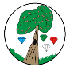 Year**: 6**  Term**: Spring 2**

**Key Facts**:

* Japan is an **archipelagic** country located in East Asia.
* Japan is made up of five main islands ([Hokkaido](https://en.wikipedia.org/wiki/Hokkaido), [**Honshu**](https://en.wikipedia.org/wiki/Honshu)**- the mainland** - [Shikoku](https://en.wikipedia.org/wiki/Shikoku), [Kyushu](https://en.wikipedia.org/wiki/Kyushu), and [Okinawa](https://en.wikipedia.org/wiki/Okinawa_Island)) and thousands of smaller ones.
* British Isles (UK)- like Japan is a **cluster of islands.**
* The British Isles consist mainly of flat or **lowlands** that phase NW into more hilly country. Due to this **topography**, humans have been able to settle throughout.
* Japan is about 20% lowland.
* Japan has over **125 million inhabitants** and is densely populated into the available lowlands.
* Japan’s terrain is mostly **rugged and mountainous** (73%).
* Japan's highest mountain is [**Mount Fuji**](https://en.wikipedia.org/wiki/Mount_Fuji) - 3,776 m (12,388 ft).
* Japan is located in the north-western [**Ring of Fire**](https://en.wikipedia.org/wiki/Ring_of_Fire)on multiple [**tectonic plates**](https://en.wikipedia.org/wiki/Tectonic_plates)
* Japan is prone to **earthquakes**, **tsunami** and **volcanoes** because of its location along the Pacific Ring of Fire.
* As many as 1,500 earthquakes are recorded yearly.
* Japan’s physical geography impacts where people live, land use, farming, the development of its society and culture.
* Japan has also suffered a number of **human-made disasters**, e.g., **Fukushima** (a nuclear plant) **nuclear** disaster, **Hiroshima** and **Nagasaki** (atomic bombings in WW2) that have impacted both the physical and human geography of Japan.

**Key Vocabulary and Glossary**:

|  |  |
| --- | --- |
| **Human Geography** | Human geography is about how people move and live, e.g., buildings, roads, cities, structures. |
| **Physical Geography** | Physical geography is the study of Earth’s natural features, e.g., oceans, forests, deserts, rivers, etc. |
| **Archipelago** | An archipelago is an area that contains a group of islands. |
| **Tectonic Plates** | Gigantic pieces of the Earth’s crust broken up into large plates across the Earth. |
| **Ring of Fire** | A chain of volcanoes that surrounds the Pacific Ocean. |
| **Tsunami** | A large wave caused by movements of the Earth’s outer layer. |
| **Nuclear Power** | A very powerful type of energy that can be used to create electricity for households or build bombs. |

**Japan**

**Enquiry Question:** How have natural and manmade

disasters impacted Japan’s physical and human geography?

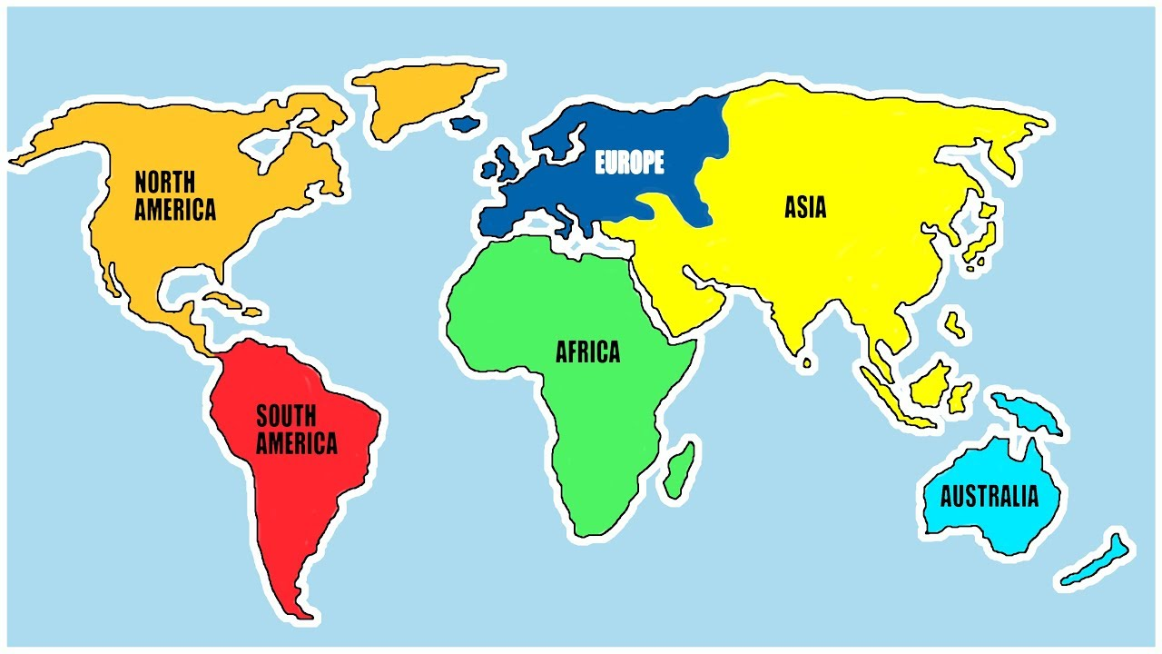

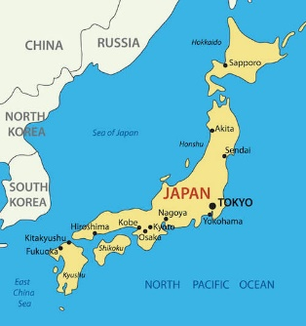

**Key Questions:**

* What is the Ring of Fire?
* How do earthquakes and volcanic eruptions take place?
* How has living with earthquakes and volcanic eruptions affected people’s lives?
* Are there any benefits to living near a volcano?
* Which have had a worse effect on the natural environment, natural or human-made disasters?

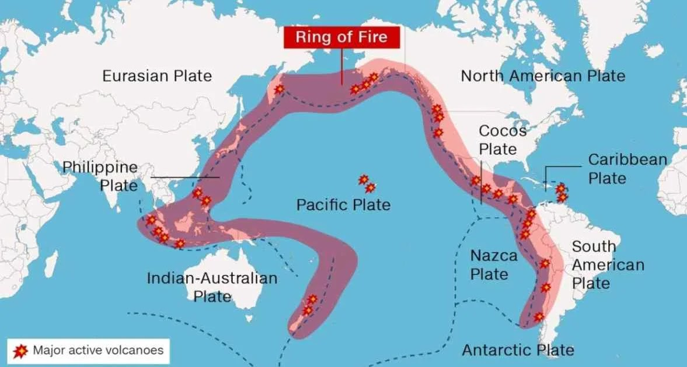

**Spring 2 – Year 6 – Japan - Homework**

*Dear Parents and Carers,*

*This term, we are going to be learning about Japan. We will be learning about what life is like in this part of the world, a place full of tradition but with a very modern outlook on life. The children will learn about its physical and human geography, developing their place and locational knowledge.*

**CLASSES 6MV and 6CS**

Homework to be completed and returned by

**Wednesday 2nd April**

**Homework Tasks**

**WRITING AND TOPIC**

You have a scrap book to use to complete your homework project. Over the next six weeks you could complete some of these activities or make some up of your own.

**TASKS**

1. Write a set of instructions for making a Japanese dish.
2. Create a Japanese comic strip.
3. Write a Japanese fact file.

**NOW CHOOSE SOME OR ALL OF THESE**

1. Create a Japanese hanging lantern.
2. Paint a cherry blossom tree.
3. Design a kimono.
4. Create a Japanese fish wind sock.

Remember, great homework will lead to lots of extra **gems** for your house!

**Places to Visit**:

The V&A –

<https://www.vam.ac.uk/>

<https://www.vam.ac.uk/exhibitions/japan-myths-to-manga>

British Museum

<https://www.britishmuseum.org/>

<https://www.britishmuseum.org/collection/galleries/japan>

<https://www.britishmuseum.org/exhibitions/hokusai-great-picture-book-everything/timeline-japanese-artist-katsushika-hokusai>

**Japan learning links:**

**BBC Teach**

# <https://www.bbc.co.uk/teach/class-clips-video/geography-ks1-ks2-your-world-tokyo-london/zv9pbdm> - Two children's lives in bustling capitals London and Tokyo

# BBC Bitesize – explore Asia - <https://www.bbc.co.uk/bitesize/topics/zyhp34j/articles/zmy7m39>

# <https://school-learningzone.co.uk/key_stage_two/ks2_geography/tokyo_and_japan/tokyo.html>

**BBC Bitesize** – what are latitude and longitude.

<https://www.bbc.co.uk/bitesize/topics/zvsfr82/articles/zxdpn9q>

**National Geographic Kids** – Japan - <https://www.natgeokids.com/uk/discover/geography/countries/facts-about-japan/>

**3D Geography** – Geography of Japan - <https://www.3dgeography.co.uk/geography-of-japan>

**Reading**

Remember to read each day and get an adult to sign your reading record. Don’t forget to collect your rewards for reading!

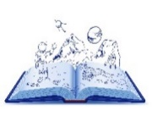



**Spelling**

Don’t forget spelling rules for your Spelling words will go home with you Friday for your collaborative test the following week!

**Recommended Reads:**

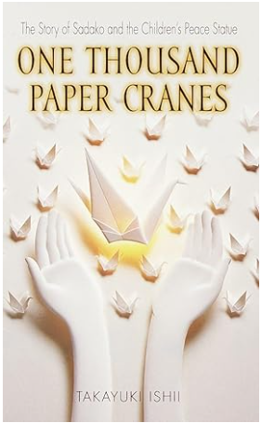 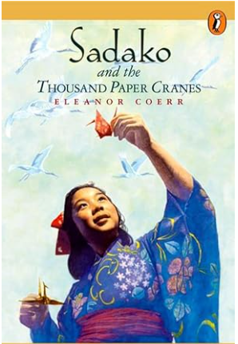 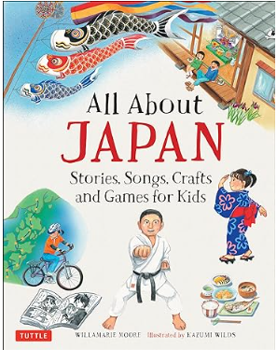 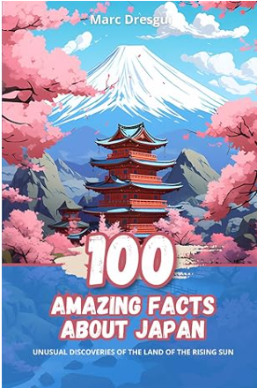

**Maths**

Remember to revise your ***time tables***.

Practice the ***number facts*** you are working on each week.

**And please don’t forget to log onto Times Table Rock Stars**