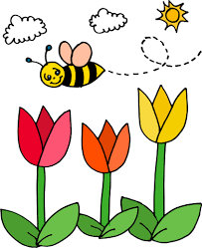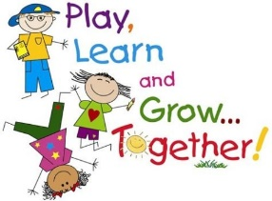**Year 1 Newsletter**

**Spring 1 2020-2021**

What a fantastic start to the academic year we have had! Thank you so much for your continued support. This newsletter will provide you with information on the half term ahead. If you have any further questions, please do not hesitate to contact the office, who will put you in touch.

We are:

1NS – Ned Symes, Amanda White

1AM – Amanda Matheson, Kathy Burston

1EB – Emily Bull, Azra Garner

***Topic***

Our Topic this term is the Polar Regions where we will be investigating the Artic and Antarctica. Our investigations will lead us on an Artic adventure where we will learn about The Artic and Antarctica, the life that can be found there, and how this differs from our life. We will continue to look at environments and discuss natural and human made objects in the world. We will be revisiting continents, and will be looking at the countries that make up the United Kingdom, and will be exploring the oceans of our world.

***Maths***

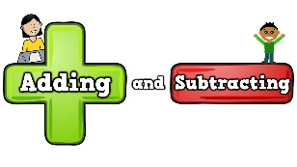

In maths we will continue to look at addition and subtraction, using concrete materials, part-part-whole mats, drawing pictures to work out answers and explore problem solving and reasoning to find answers and justify them. We will also be continuing to look at place value up to 50, and the composition of these numbers.

We will continue to use concrete resources to deepen our understanding and ensure we are able to use different counting strategies to find the total amount, and counting out how many ‘tens’ and how many ‘extra ones’ make up a number. (eg. 16 is one group of ten and six extra ones).

It would be great if you could keep exposing children to the language of time, as we will begin to start telling time to o’clock and half past in the coming terms. Later in the term we will be looking at measuring length and height as well as weight and volume.

***English***

This term we will be studying the stories Lost and Found and Dear Greenpeace.

We will be writing letters, post cards, drawing story maps and rewriting familiar stories… and even tweaking them to make them our own. We will continue to talk about nouns, verbs, adjectives, and adverbs.

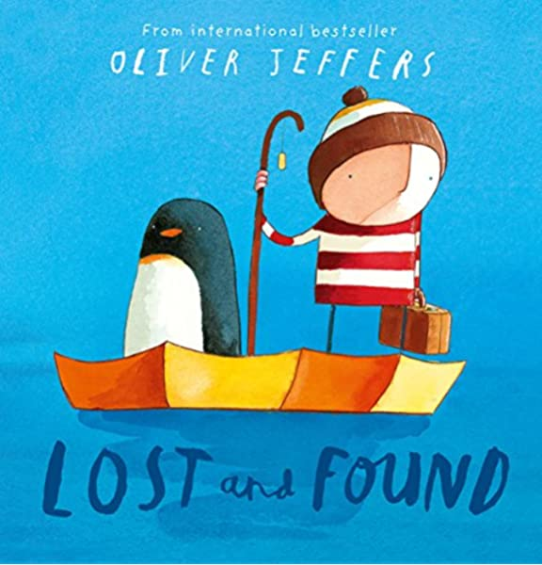 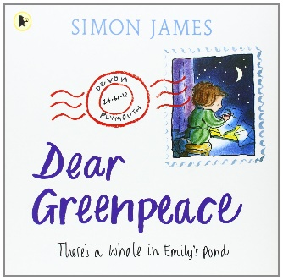

**Reading**

We cannot stress enough the importance of having your child read to you daily. We are asking for a minimum of 10 minutes each day. It is noticeable when children are reading regularly at home and they are proud to share this with the class. When your child is confident with their home reader, please send it back in so we can change it and send a new one home.



***Science***

This term we are discussing properties of materials. We will be looking at what objects are made of and why that material is suitable for its purpose. We will sort these materials and group them by their properties discuss what items we could make with those materials. At the end of term, we will make a boat in DT out of suitable materials. Please send in any junk modelling materials that we could use for our boats.

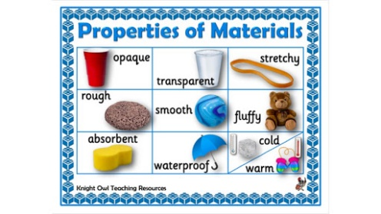

***P.E***

For the first half of the Spring term we will be having one outdoor and one indoor PE session. This may mean that the PE days change on occasion. Please look out for further notices about this. Our outdoor sessions could be chilly so please send your child in warm clothes on these days e.g. jogging bottoms and a jumper.

|  |  |  |  |
| --- | --- | --- | --- |
|  | 1NS | 1AM | 1EB |
| Indoor | Thursday | Tuesday | Wednesday |
| Outdoor | Wednesday | Monday | Monday |

**REQUESTS**

If you have any items that we can use for junk modelling, they would be much appreciated. We will leave a box outside the classrooms to decontaminate for a week before they are used.

Thank you all for your continued support in your child’s learning journey. We look forward to the fun filled term ahead.

The Year 1 Team 😊