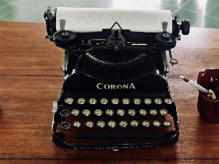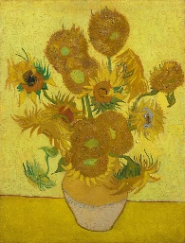**Year 1 Newsletter**

**Autumn 1**

**2022-2023**

Welcome back! It is so nice to meet all of you. We hope that you all had a wonderful summer break and are ready for another fun filled school year ahead. This newsletter will provide you with information on the upcoming half term. If you have any further queries, please do not hesitate to ask.

We are:

Teachers 1HE: Hannah 1AJ: Abbie Supporting Teacher: Ellie

Supporting us with our learning: Oyin, Fatima

**Date for the diary**

**Phonics and Reading celebration morning - Tuesday 27th September 9.10am**

We will be holding a phonics/reading celebration morning on the above date. Each class will showcase their phonics learning with all of their parents as an audience. The teachers will then explain a little bit more about how we teach and help the children learn to read. We would really appreciate you coming along so that you can best support your child at home with their reading skills. We will then set up some activities linked to reading that you can access with your child afterwards – they would love you to come and join in the fun with them.

**Reading**

It is very important for children to practise reading every day. Through reading children are able to access the world around them and supports the development in all other areas. It is also important to foster a love for reading and we ask that you read a variety of stories to them that they enjoy. If you have any spare time we would love for you to take your child to the library where they can explore lots of different reading materials and stories.

You will have received your reading book and diary, it is expected that children bring both their reading diary and reading book into class every day. They will need to get these out of their bags and place them into a reading box. Your child’s reading diary should be signed every time your child is reading at home this should be **every day** to best benefit your child. This could be a book, magazine, a newspaper of their choice or their reader from school. We are going to be giving out rewards for every five reads they do at home. This can only be monitored if the reading diary is being signed and is coming to school every day.

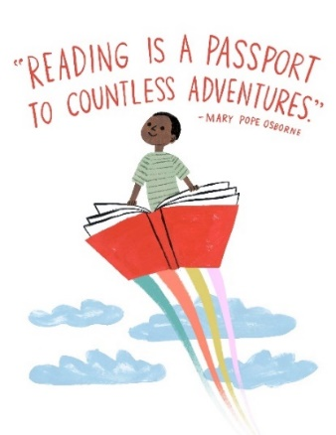 We will read every day with a group of children and if your child forgets their book it may mean that they miss out on reading with an adult that day. When your child is read to a comment will be left inside their reading diary, this will explain how your child is getting on and whether or not they are ready for a new book. We will not be giving your child a new book until they are ready for one so this may mean that your child has the book for a few weeks or it might mean that they get to change their book every time they are read to. If you are unsure please do not hesitate to ask we are always here to help.

***Topic***

Our topic this term is ‘All About Me” where we will be looking at what makes us unique and wonderful, our likes and dislikes and how we are similar and different to each other. We have begun this term by reading the book Colour Monster by Anna Llenas and have been exploring different emotions and why we might feel differently at different times. This week we are going to start the book ‘Here We Are’ by Oliver Jeffers which explores the world around us. We will discuss our local environment along with natural and manmade objects. We will also discuss our place in the world around us using this book as a guide.

The focus of our topic this half term will be on history. We will be talking about what life was like when our grandparents were young and how this might be the same or different to our lives now. In our classroom at the moment we have a few things from the past such as an old-fashioned camera, video tapes and a minors lamp but if you have anything at home that is old such as an old telephone, brick mobile phone, typewriter etc… that you wouldn’t mind donating to the school for the children to explore, that would be greatly appreciated.

**Art project**

This year’s art project theme is Still Life. We have chosen to look at Andy Warhols interpretation of Pop Art and have been trying to make our very own version using fruit as our inspiration. So far, we have looked closely at the colours Andy Warhol chose and the different popular items he used as the subjects of his art work. For our final project we are going to create our own printing squares where we will use our favourite fruit as the printing pattern. Keep an eye out on the website for some updates!

***Science***

In the first part of this term we are going to be labelling our body parts and exploring our five senses and then later on in the term we will begin our yearlong study of the weather and seasonal change. We will begin to track weather patterns for each month and we will be creating our own wind vane and rain gauge to further our knowledge around weather and seasons.

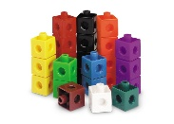***Maths***

In maths we are beginning with ‘Place Value’ through number recognition and representing numbers in various ways with different objects. We use concrete resources from our environment to deepen our understanding and ensure we are able to use learnt counting strategies to find the total amount.

Why not do some baking at home, count how many seconds your child can brush their teeth for, how many jumps they can do in 30 seconds, count and name coins, look at door and bus numbers and other numbers in our everyday environment to further reinforce these mathematical skills and knowledge?

In the coming week your child will receive their Mathletics and Reading Eggs login details via email. We encourage you to log on and practice these with your child. These are online programs that can be used at home to support the learning that we do in school.

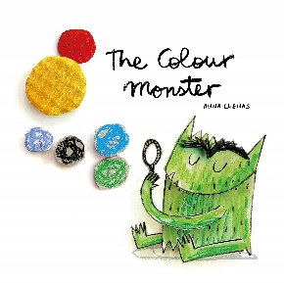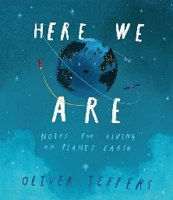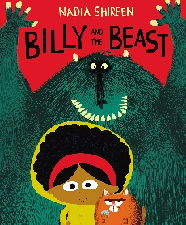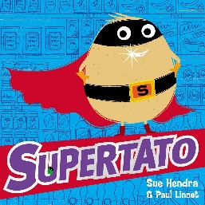***English***

We have started this term by reading ‘The Colour Monster’ and ‘Here we are’. In the coming weeks we will also be reading Supertato and Billy and Beast.

***P.E***

Every Wednesday is your child’s PE session. We ask that you bring a labelled PE kit in for your child. This kit must be in a **NAMED BAG** have a named T-shirt, some shorts or leggings and trainers or plimsolls. This kit needs to come in **EVERY WEDNESDAY**. Please do not send your child in their P.E kit.

|  |
| --- |
| **Daily timetable:** |
| **8.55–9:10** Register/ Handwriting  **9.10–9:40** English/Maths  **9:40-10:50 -** COOL Time (Choose Our Own Learning)  **10.50-11:20**  - Phonics  **11:20-11:45 -**  COOL Time  **11:45- 12:00-** carpet time  **LUNCH**  **1:00-1.30** Topic/Science/Computing/P.E/Art/PSHE  **1.30- 2.50-** COOL Time  **2.50-3.30**- Story/ Discussion/ Daily PE activities  **3.30**- Home time |

**Home Learning**

We will be sending out home learning task on google classroom, please make sure you have accepted the invitation and signed up to google classroom.

We would love to celebrate any learning that has happened at home in our classrooms.

**REQUESTS**

**Please label all of your child’s uniform and their water bottle.**

We are looking at expanding our learning provisions and are wondering if you have any of these things available directly, or through friends or other family members.

* Old objects - such as a type writer, tape player/tapes, old telephone, brick mobiles
* Tyres
* Pipes, straight and bendy
* Cable reels
* Crates
* Bread crates
* Astro turf
* Old pots and pans

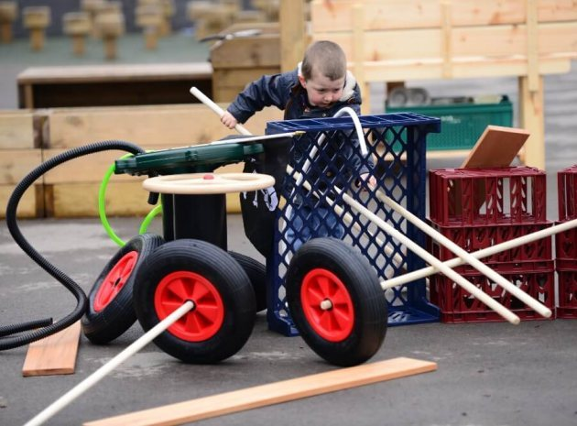 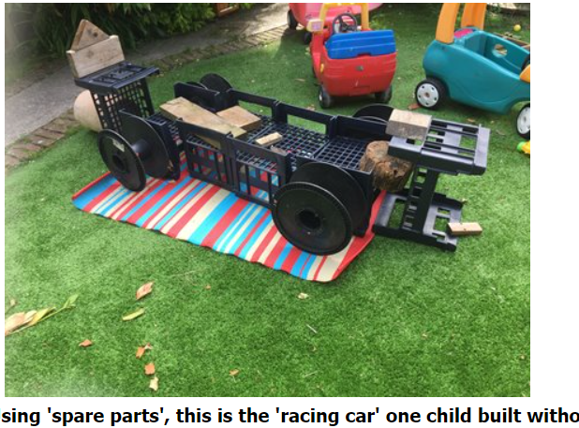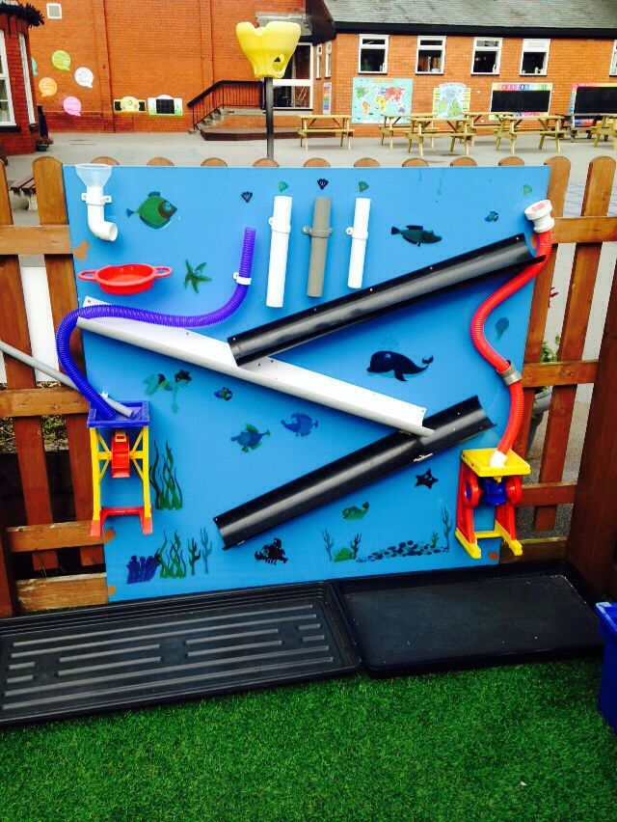

If you have any items that we can use for junk modelling, they would be much appreciated. We will leave a box outside the classroom for these to be placed in at home time.

We look forward to a fun filled year ahead. Please speak to a member of the year one team at home time if you have any questions. Thank you all for your support in your child’s learning journey. We look forward to getting to know you and your child this year.

The Year 1 Team