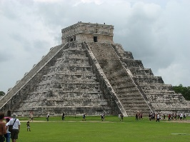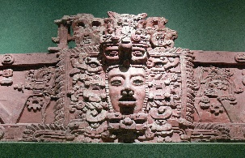Year**: 6**  Term**: Spring 1**

**Key Questions:**

Why do we study the Maya in history?

How did the Maya manage to become so important?

What was everyday life in Mayan civilization?

How can we know what was life like for the Mayan people 1,000 years ago?

If the Maya were so civilized why then did they carry out human sacrifice?

Why did the Mayan empire decline?

**Key Vocabulary and Glossary**:

**Glossary**:

|  |  |
| --- | --- |
| Cenote | Sink hole formed by collapse of rock into which Maya threw offerings |
| Codex plural is codices | Collection of manuscript pages held together into early form of book |
| Glyph | Written symbol used to present spoken words |
| Jade | Green stone used to make wonderful jewels |
| Obsidian | Black glassy rock formed when volcanic lava cools |
| Quetzal | Colourful tropical bird very important to the Maya |
| Ritual | Act that is always performed in same way as part of a religious ceremony |
| Slash and Burn | Way of clearing farmland by slashing away most vegetation then burning the rest |
| Stelae | Upright stone slabs or pillars with inscriptions or design |

**The Maya**

**Enquiry Question: Who were the Maya and what happened to them in AD900?**

**Key Facts**:

* In the year 1000 settlements like Chichen Itza were among the largest settlements anywhere in the world and Chichen Itza is probably the best preserved of any city in the world from this time.
* After about the year AD830 very little new construction took place at Chichen Itza. The last glyph with a date on comes from AD910.The reasons why the Mayan declined at that time (they weren’t entirely wiped out) was probably due to drought and overworking of the soil.
* The Mayans farmed on land they terraced and made fertile. Their staple diet was maize and they even worshiped maize as a god. They drank chocolate but not as we know it. It was unsweetened and spiced with chilli peppers. They even had a frother!
* They built pyramids with temples on top and even had an amazing astronomical observatory.
* The Maya worshipped many gods and believed they needed offerings of blood.
* We know about the Maya from their writings in hieroglyphics, their advanced number system and the buildings such as the ball court that are still there today.

|  |  |  |  |  |  |  |
| --- | --- | --- | --- | --- | --- | --- |
| **2000 BC** | **500 BC** | **250 BC** | **650 AD** | **900 AD** | **1500 AD** | **1952 AD** |
| Maya start to develop religious ideas | First Large Settlements | Pakal builds Palenque pyramids | Cgichen Itza ball court | Tikal, Copan, Palenque abandoned | Spanish conquest | Tomb of Pakal is discovered inside of a pyramid |

1000 AD/ACE

1 AD/ACE

2000 BC/BCE

**British History**

5000 BC/BCE

**World History**

Romans

Bronze Age

Stone Age

Ancient Sumer

Roman Britain

Anglo-Saxons and Vikings

Iron Age

Indus Valley

Shang Dynasty

Ancient Greece

Ancient Egypt

Maya

**CLASSES 6LM, 6SB and 6KL**

Homework to be completed and returned by:

WEDNESDAY 12th FEBRUARY

**Spring 1 – Year 6 – Maya - Homework**

*Dear Parents and Carers,*

*In the Spring term, we will be learning all about the Maya. Children will be learning all about the advancements and innovations of this amazing civilisation. Homework can be completed independently or with an adult.*

**Places to Visit**:

The British Museum: Great Russell St, London WC1B 3DG

**Maya learning links:**

<https://www.bbc.co.uk/bitesize/topics/zq6svcw>

<https://www.mayaarchaeologist.co.uk/school-resources/maya-world/maya-timeline/>

<https://www.dkfindout.com/uk/history/mayans/>

**Ancient Maya – Homework Tasks**

You have a scrap book to use to complete your homework project. Over the next six weeks you may wish to complete some of these activities or make some up of your own.

**Writing:**

* Research the Maya gods and goddesses. Who were they? What did they represent?
* Write a rule book with diagrams to support your instructions on how to play the Mayan ball game ‘Pok-a-Tok·.
* Create a fact file based around one of these topics: Mayan gods and religious beliefs, Mayan food and farming, Mayan music or Mayan calendars.

**Art/DT**

* Build your own Mayan temple using materials you have at home.
* The Mayans loved chocolate! Can you find out about how chocolate is made? Maybe you could even create your own chocolate bar.
* Learn how to play the Maya game of Pok a Tok. Can you create your own set of instructions on how to play this?
* Create a Mayan board game.
* The Maya loved the idea of simple repeating patterns. Can you create your own?
* Design and create a Mayan mask or headdress.

**Reading**

Remember to read each day and get an adult to sign your reading record. Don’t forget to collect your rewards for reading!

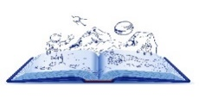

**Spelling**

Don’t forget spelling rules for your Spelling words will go

home with you Friday for your quiz the following week!



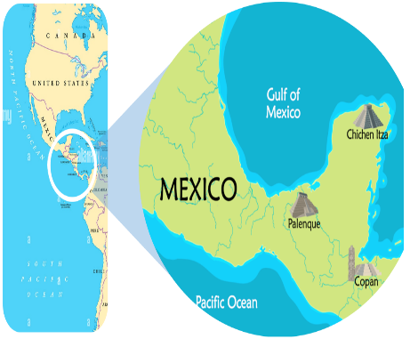

**Maths**

Please complete the given question in your SATS revision guides each week.

**And please don’t forget to log onto Times Table Rock Stars.**

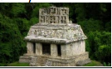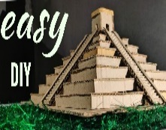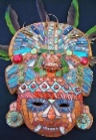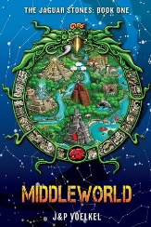

**Recommended Reads:**

**Learn about the Maya**  Maya **Historical Fiction**:

