Reception 2022 Newsletter
Welcome to Reception! It is so nice to meet all of you. We would like to thank you for your cooperation, you have helped the transition process to run smoothly. We are all very proud of the children and they have settled in very well. We would like to keep you up to date with a few routines and policies for Reception. If you have any further queries, please do not hesitate to ask.
Workshops

We will running parent workshops and or celebration days over the course of the year. Please check your child’s classroom door or the whole school newsletter for any upcoming events.

Culture and Diversity Celebration Day – Thursday 22nd September 1:30PM
Phonics and Reading Workshop – Wednesday 28th September 9AM
Reading
It is very important for children to practise reading every day. Through reading children are able to access the world around them and supports the development in all other areas. It is also important to foster a love for reading and we ask that you read a variety of stories to them that they enjoy. If you have any spare time we would love for you to take your child to the library where they can explore lots of different reading materials and stories.
You will have received your reading book and diary, it is expected that children bring both their reading diary and reading book into class every day. They will need to get these out of their bags and place them into a reading box. Your child’s reading diary should be signed every time your child is reading at home this should be every day to best benefit your child. We are going to be giving out rewards for every five reads they do at home. This can only be monitored if the reading diary is being signed and is coming to school every day.
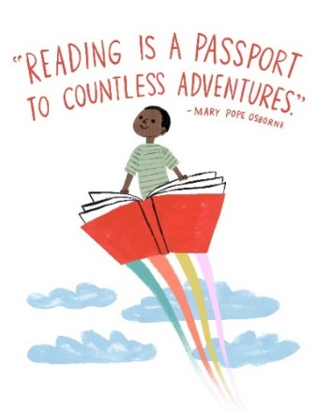
We will read every day with a group of children and if your child forgets their book it may mean that they miss out on reading with an adult that day. When your child is read to a comment will be left inside their reading diary, this will explain how your child is getting on and whether or not they are ready for a new book. We will not be giving your child a new book until they are ready for one so this may mean that your child has the book for a few weeks, or it might mean that they get to change their book every time they are read to. If you are unsure, please do not hesitate to ask we are always here to help.
Please see the reading letter we have placed inside your child’s reading diary for some more information about reading at home.
Literacy Key Texts
We have started this term by reading ‘Za-za’s baby brother’. In the coming weeks we will also be reading My hair, Sharing a shell and Riley can be anything.
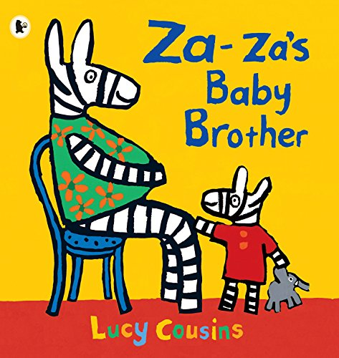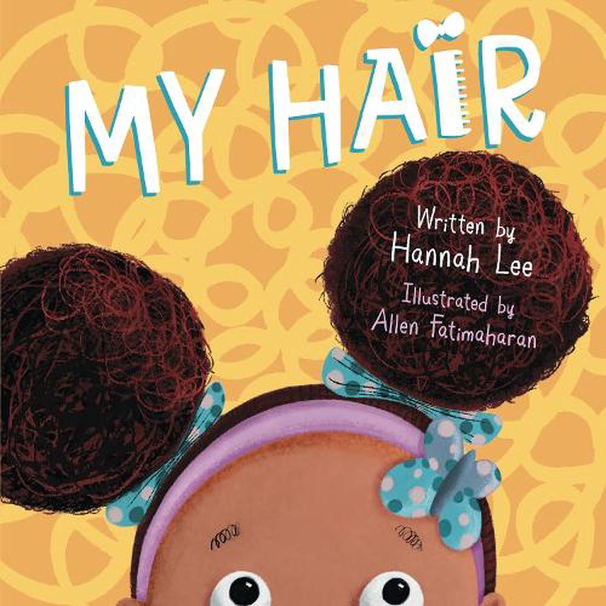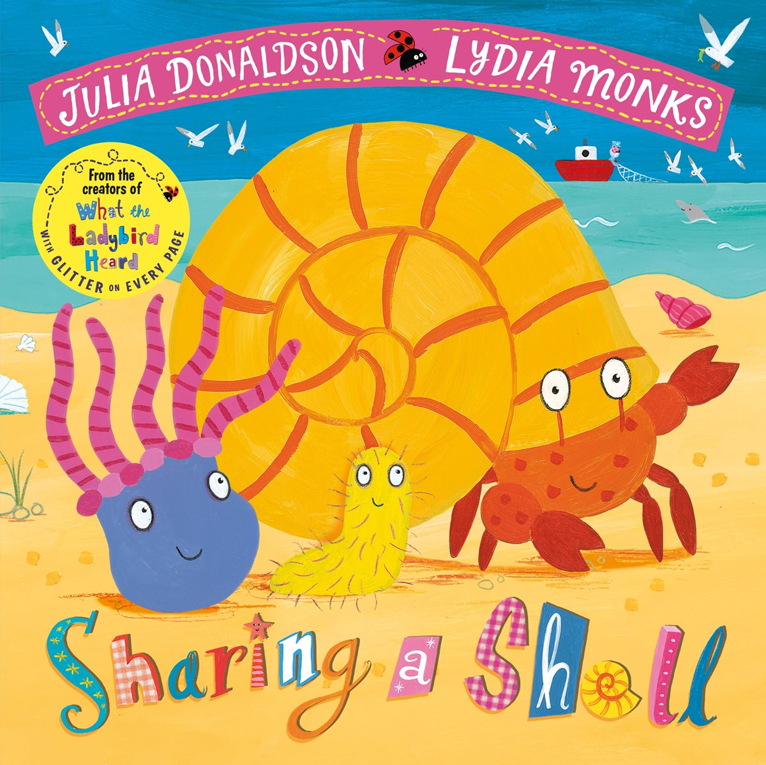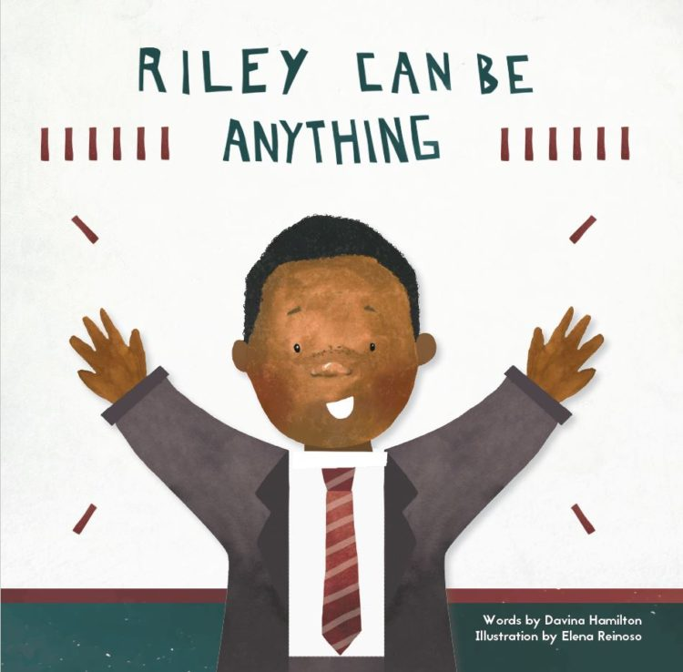
Topic
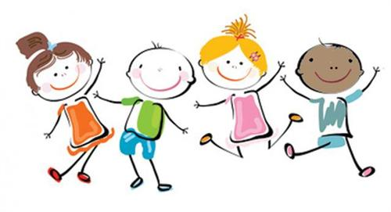
This term Reception are focusing on identity and will be exploring the topic ‘My story, my world’. We will be looking at our similarities and differences and sharing our experiences within our families. We will also discuss the roles people play in our community and how they help us. We will also be looking at different celebrations and how we celebrate different occasions. This is an exciting topic, and we welcome any ideas that you may have around this learning experience.
PE

Children will not be required to change for PE until after the Christmas holidays. Please ensure that your child is therefore fully able to dress and undress themselves for PE without the aid of an adult.

PE will usually take place on either a Monday or Tuesday.
Food
Packed lunch
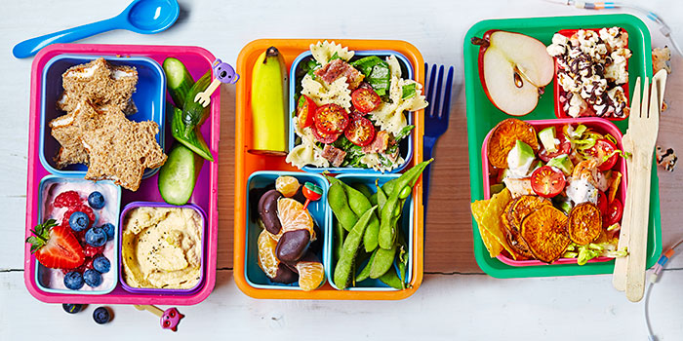
If your child requires a packed lunch, it is to be placed inside the classroom. These lunches should be healthy, containing a sandwich, fruit and some dairy. Please refrain from bringing in sweets, crisp and chocolate as these are not considered healthy options. We are a nut free school.
A few ideas can be found at the following website: https://www.bbcgoodfood.com/howto/guide/school-packed-lunch-inspiration
Breakfast
We will be offering the children breakfast in class in the mornings. There will be a selection of cereal and toasted bagels available. If your child/children require alternative milk then please feel free to bring it in to school. Please note we are nut free school so we cannot accept almond milk.
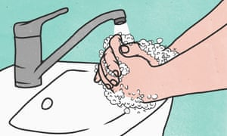
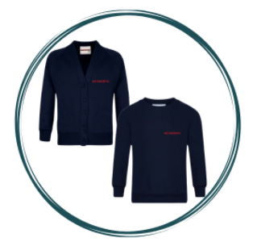
Uniform and Personal Hygiene

Please make sure you have written your child’s name in each piece of uniform, including shoes, water bottles and jackets. It is essential that all children come to school with their own water bottle to remain hydrated throughout the day, these must be clearly labelled.
We encourage children to put their items in their trays, however, we are not responsible for any loss of items at school. Please also be aware, that although we will encourage your children to wear an apron they will at times come home with unclean uniform and this is an indication that they have had a good day and have taken the opportunity to explore the exciting provision that we have in our reception classroom.
Home Learning
We will be sending out home learning tasks on google classroom, please make sure you have accepted the invitation and signed up to google classroom.
We would love to celebrate any learning that has happened at home in our classrooms so please post photos in the stream so that we can share these in class.
Requests
We are looking at expanding our learning provisions and are wondering if you have any of these things available directly, or through friends or other family members.
Old objects - such as a typewriter, tape player/tapes, old telephone, brick mobiles
Tyres
Pipes, straight and bendy
Cable reels
Crates
Bread crates
Astro turf
Old pots and pans
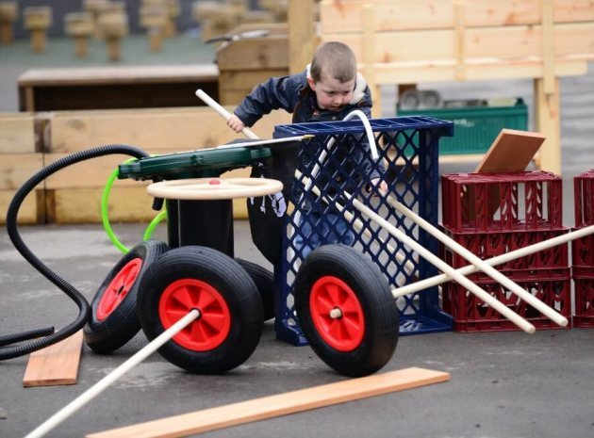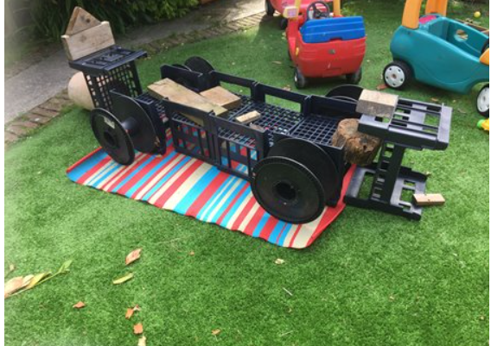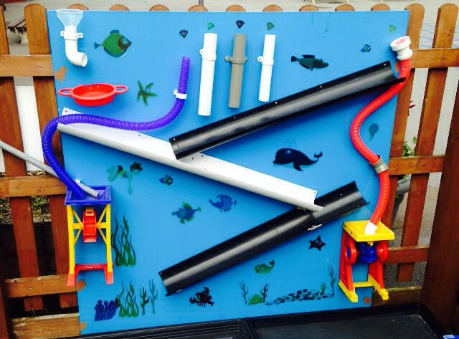
If you have any items that we can use for junk modelling, they would be much appreciated. We will leave a box outside the classroom for these to be placed in at home time.
We look forward to a fun filled year ahead. Please speak to a member of the reception team at home time if you have any questions. Thank you for your continued support in helping your child settle in and learn their new routines.
We look forward to getting to know you and your child this year.
The Reception Team ☺

