Little Stars Nursery
Nursery Provision for 2 year olds

Dear Little Stars Families,

A big hello to all our new children and their parents who have joined Little Stars this term.

Our Topic this half term is ‘Celebrations’, which will use to explore various significant celebrations that we celebrate throughout the year such as birthdays, cultural events etc.
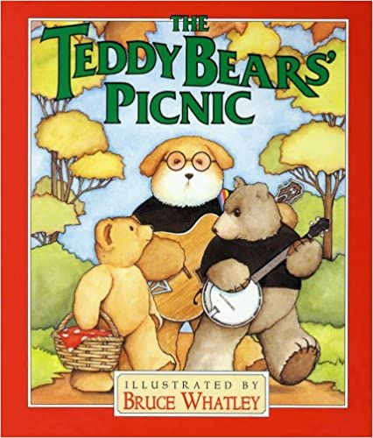
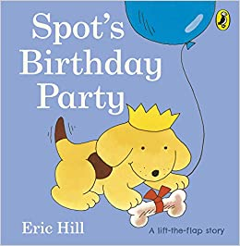
The books we will be focussing on this half term are:

We will use the topic ‘celebrations’ to encourage children to share their special cultural events from around the world with their friends. We will be looking at the various different events that take place such as Eid, Christmas, Diwali etc.

Using role play activities such as birthday parties where we will encourage the children to create birthday party invitations using a variety of different art resources. They will then have the opportunity to hold a teddy bears birthday party, encouraging sharing amongst each other, extending and introducing different vocabulary. This will also help children develop in a variety of areas, but this will especially help children to build confidence and a positive sense of self.

Celebrations display
It would be lovely to add children’s pictures to our topic board. Pictures of children celebrating at home with friends and family for example. If you have any pictures please email them in so we can get those added.

Ways to support children in their play
- Have discussions with children about what types of celebrations take place within your family.
- Hold a teddy bears birthday party at home.
- Sing songs around celebrations at home such a happy birthday to you or cultural songs which we would love to hear at nursery.
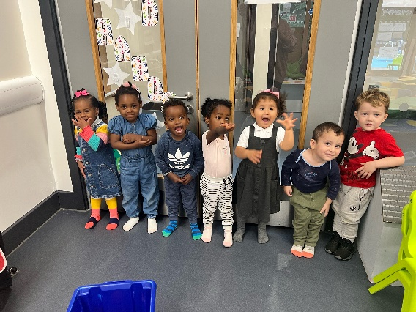
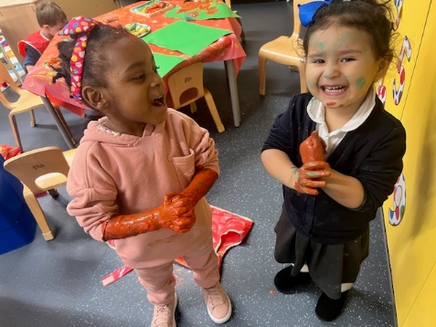

Ways to help us in the setting
- Please remember to pack extra clothes in your child’s bag ready for them to explore messy activities.
- Ensure that you are providing nappies for your child, if your child is toilet training then please send them in pull-ups so we can help support them in the setting.
- When out and about, please collect any pine cones, small logs and conkers we will be making activities using natural materials.
- We are always in need of spare clothes, if you have any spare clothes that can be donated to school please bring them into school they would be gratefully appreciated.
- Please do not use your mobile phone cameras on school premises when collecting your children

If you have any questions then please feel free to ask the Little Stars staff at the beginning or end of the day.

Many thanks- Little Stars Team

