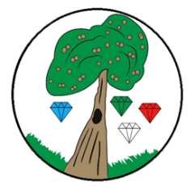Year**: 6** Term**: Spring 2**

**Science: Animals including Humans**

Pre-Learning Pack

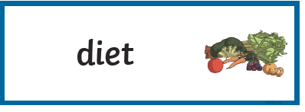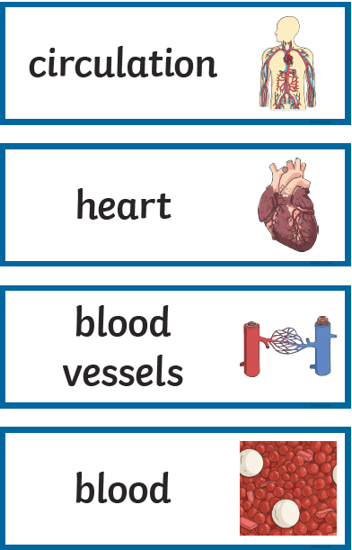

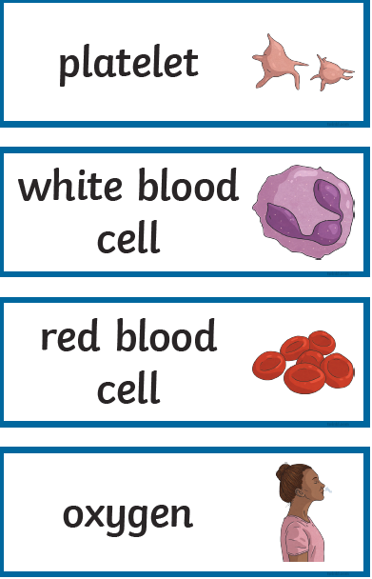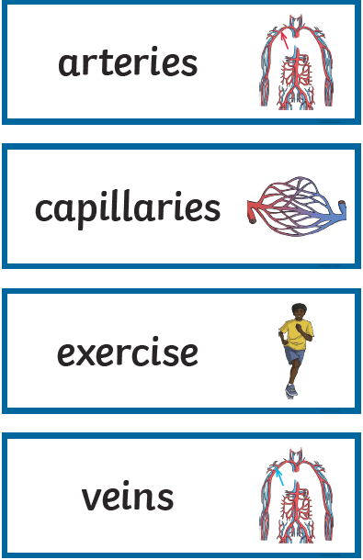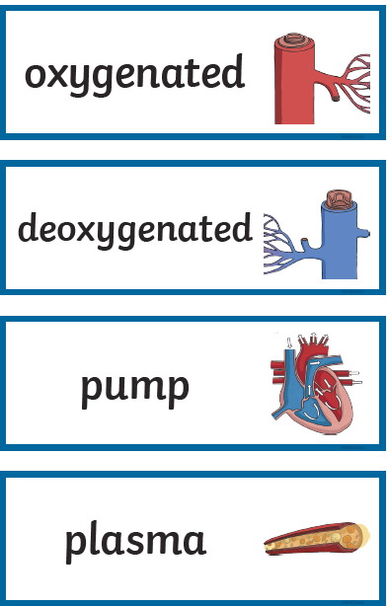



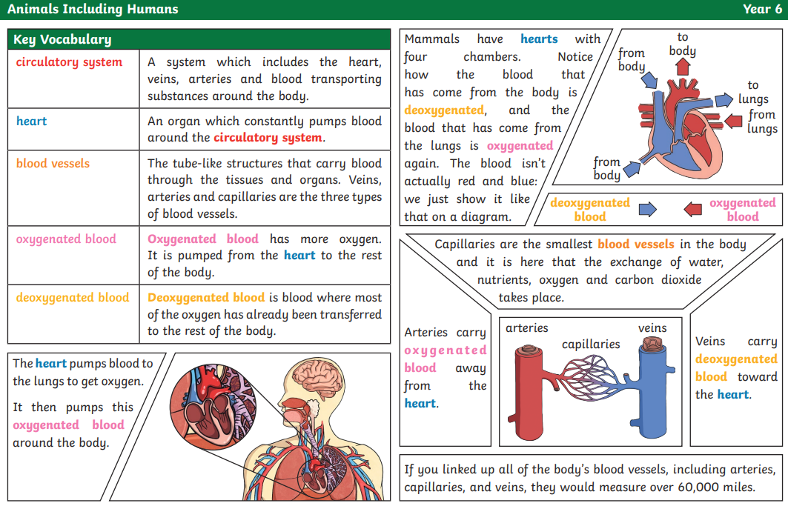

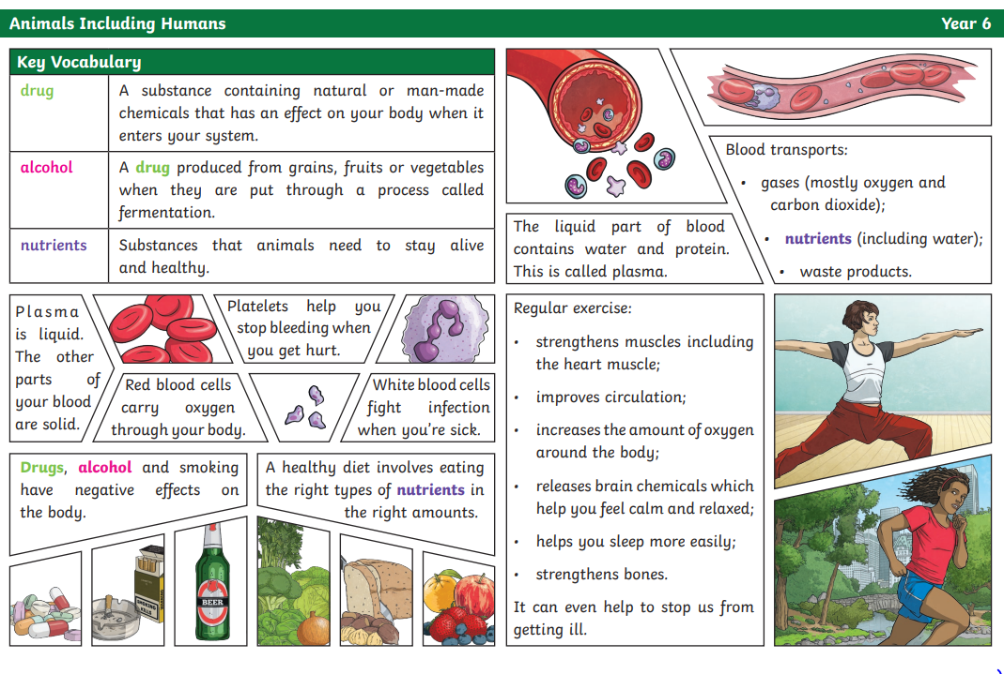

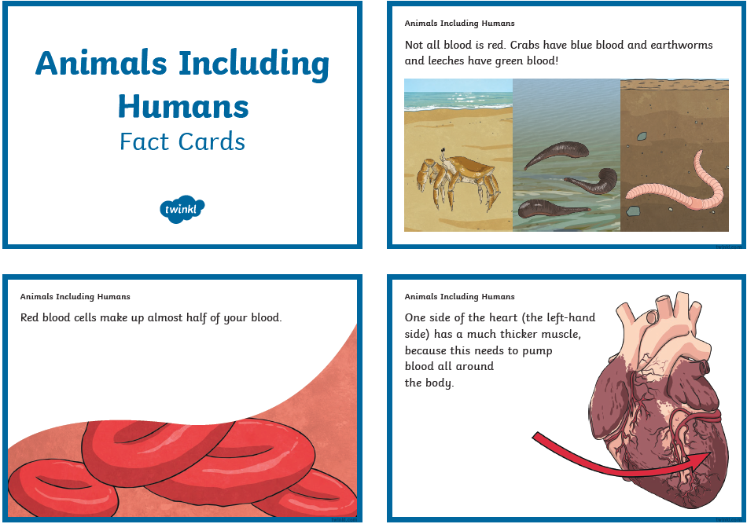

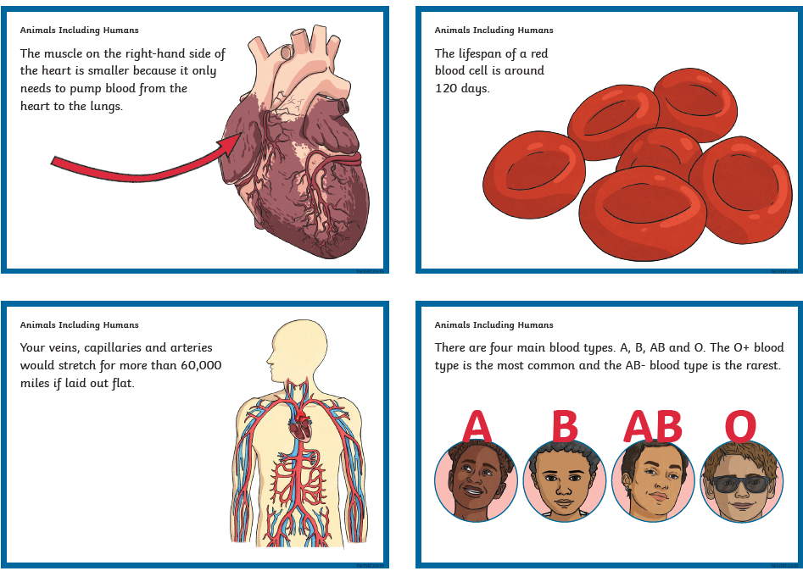

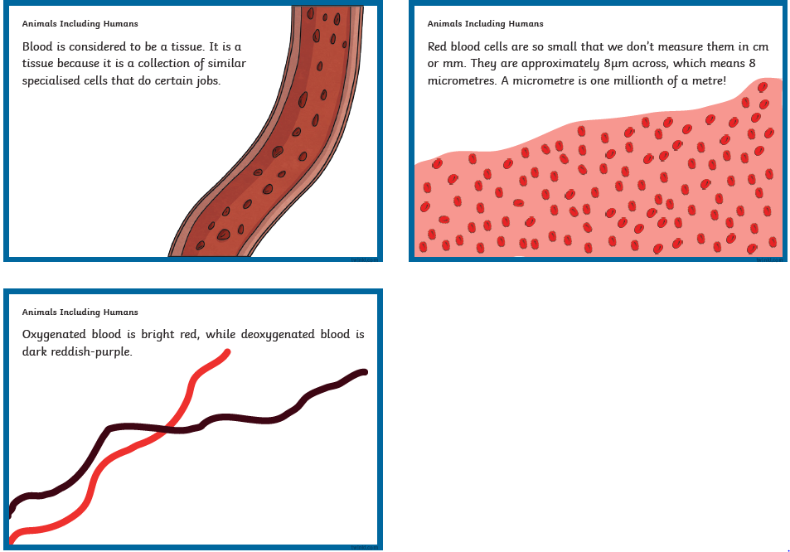

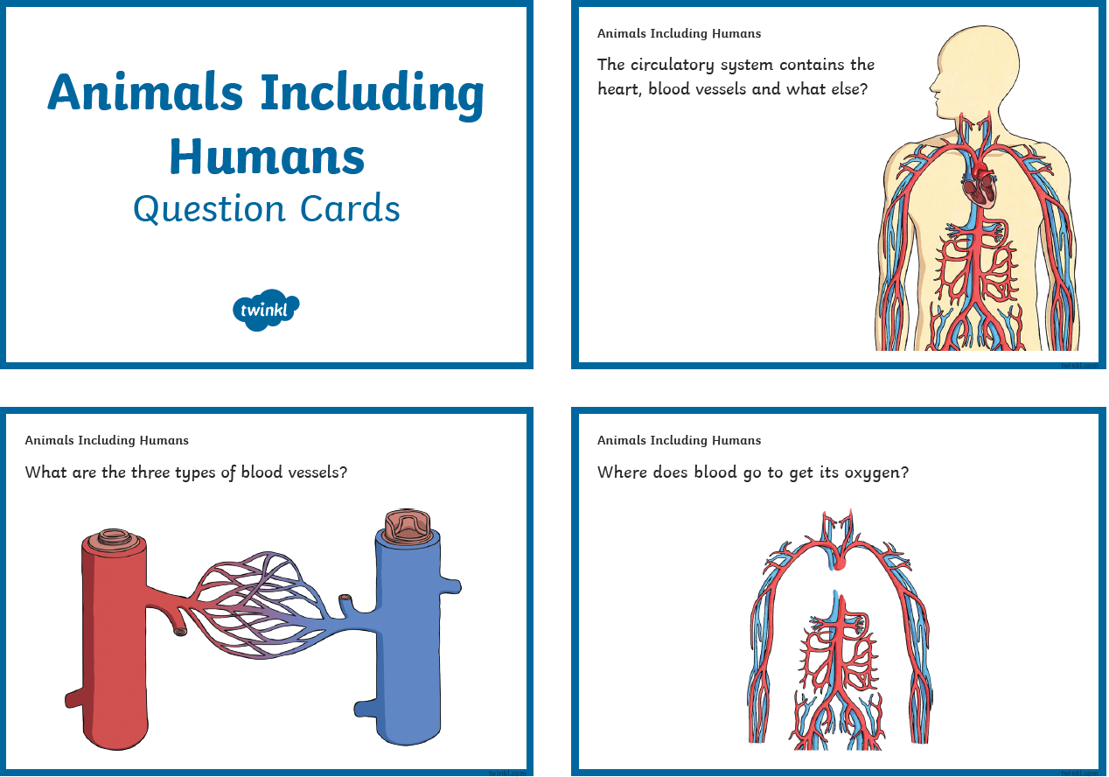

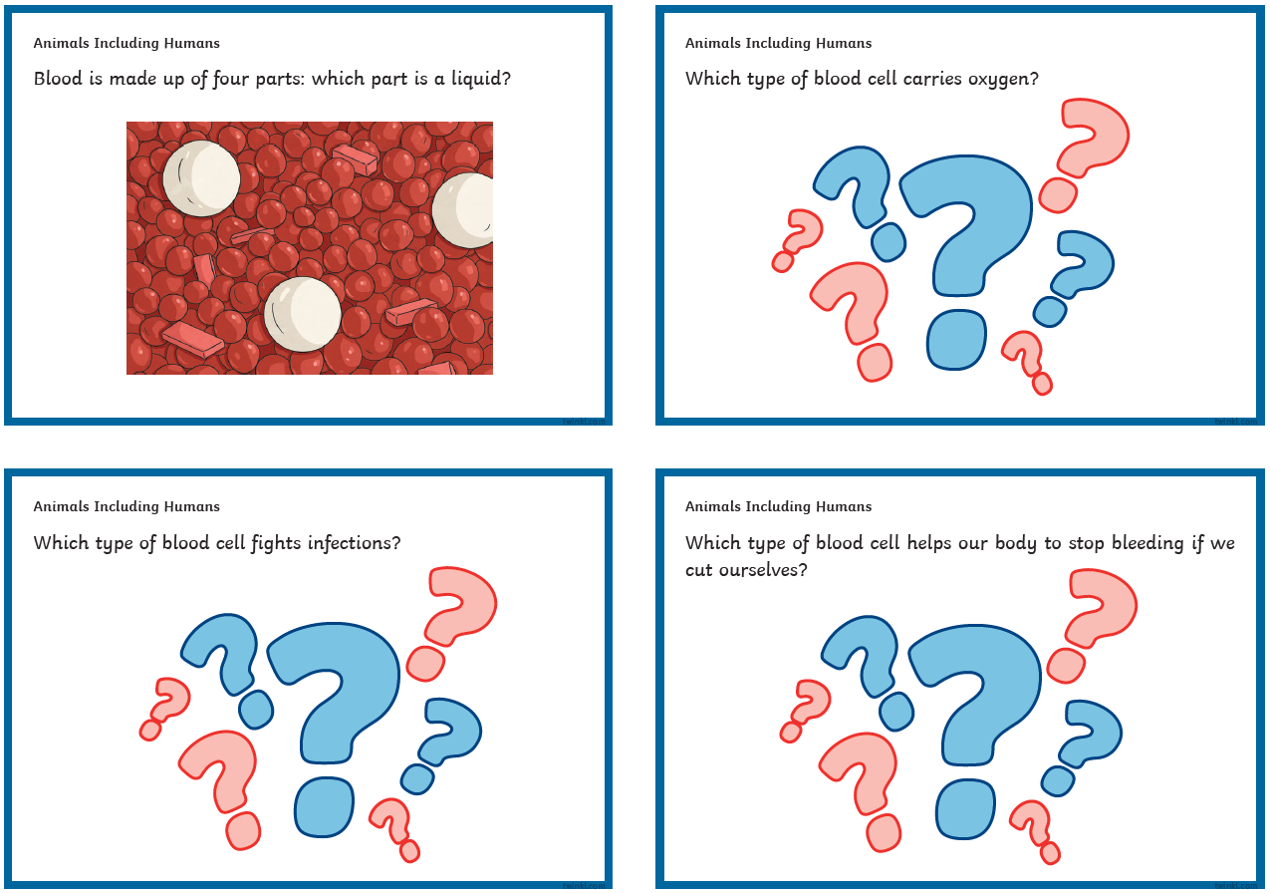

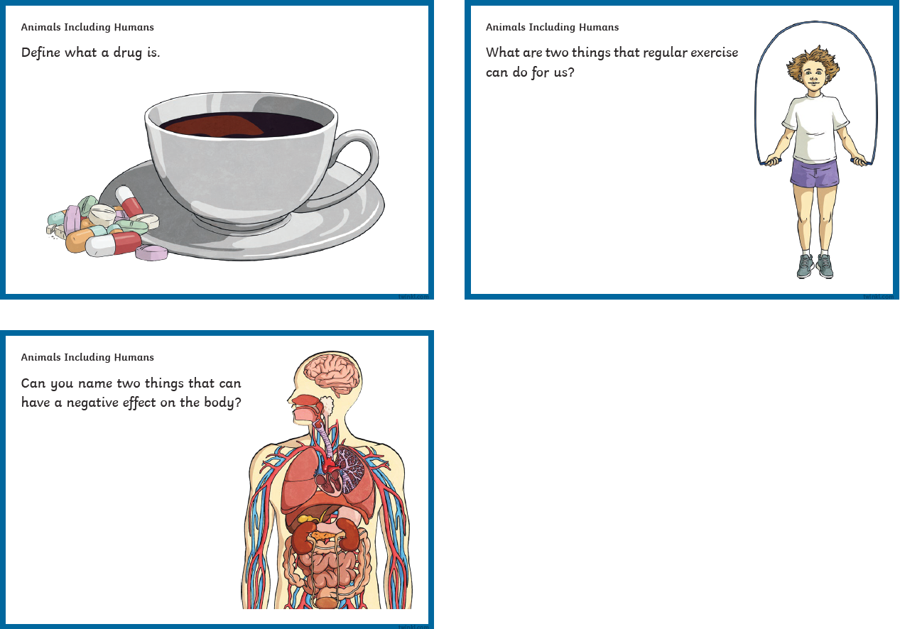

|  |  |  |
| --- | --- | --- |
|  | **Videos** | **Activity suggestions** |
| **Animals including**  **Humans** | The circulatory system: <https://www.youtube.com/watch?v=mC7-XXmbF90>The circulatory system - BBC Bitesize<https://www.bbc.co.uk/bitesize/topics/zcyycdm/articles/z9w9r2p> **Watch animation of William Harvey’s discovery** <https://www.youtube.com/watch?v=bIGB8aooakE>Transport of nutrients and water – BBC Bitesize | Out and about – the local area  - Pupils can design an animal that would thrive in their local environment.  Out and about  - Visit the Natural History Museum in London and take a self-guided tour and/or book onto their 45 minute ‘Evolution Workshop’ |