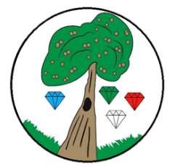Year**: 5** Term**: Spring 2**

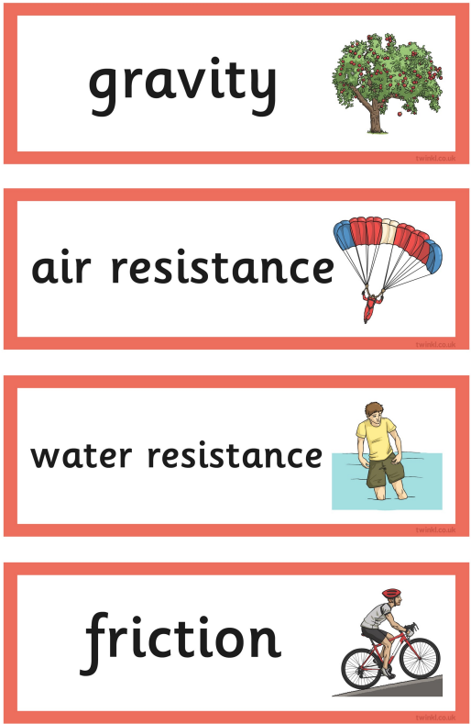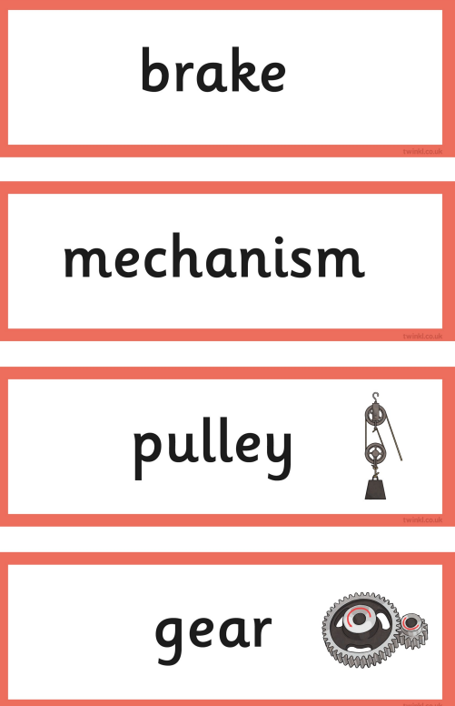

**Science: Forces**

Pre-Learning Pack

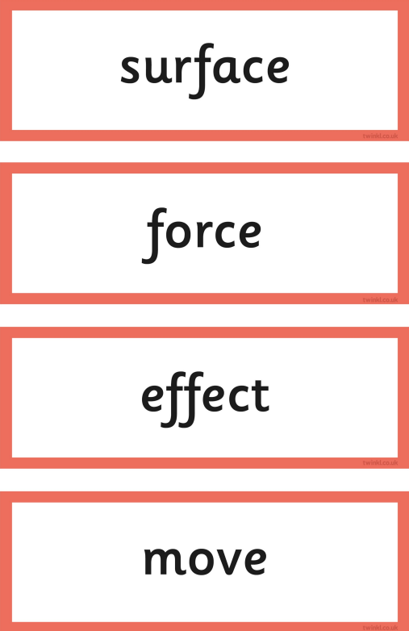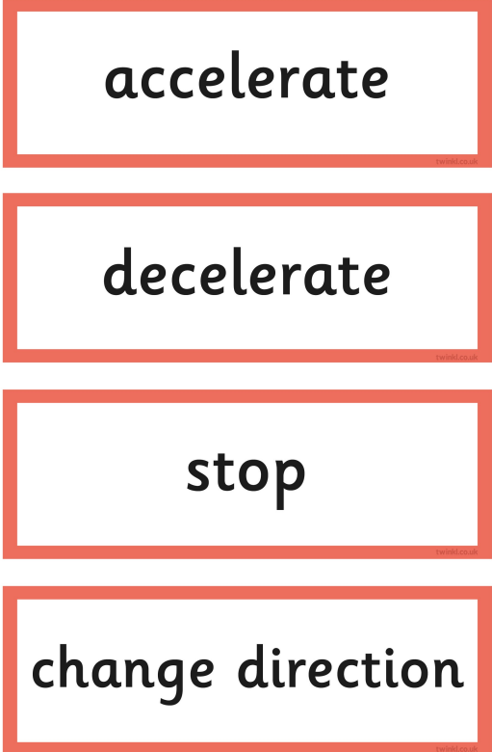

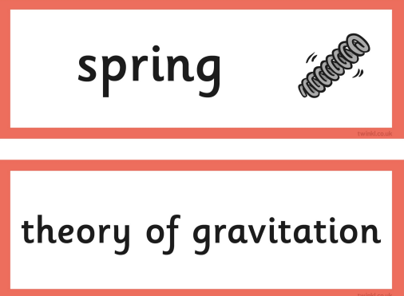

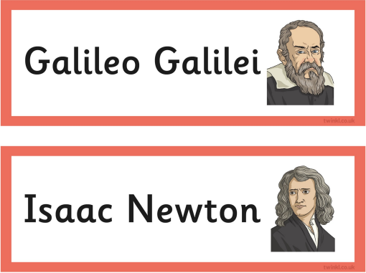

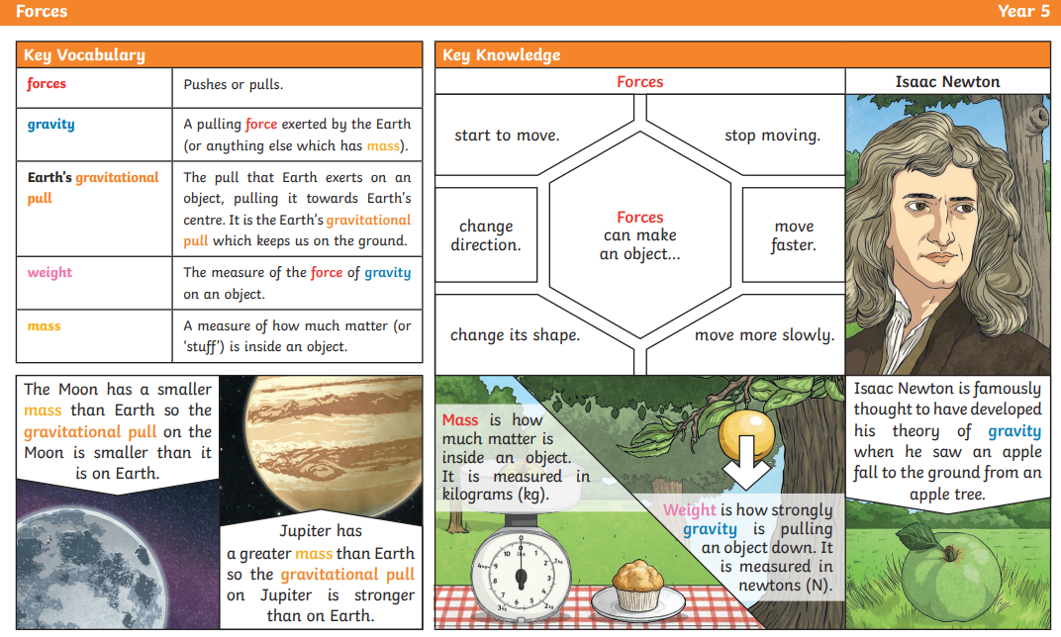

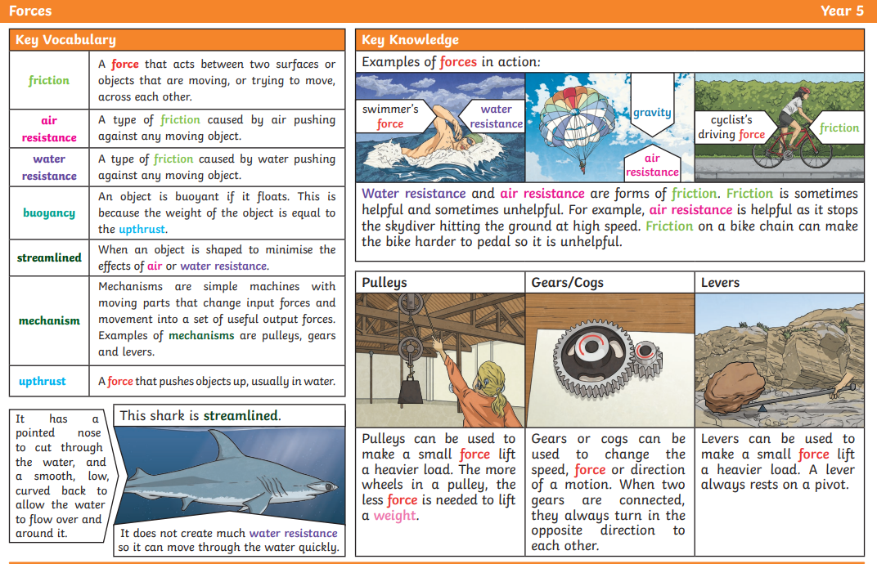

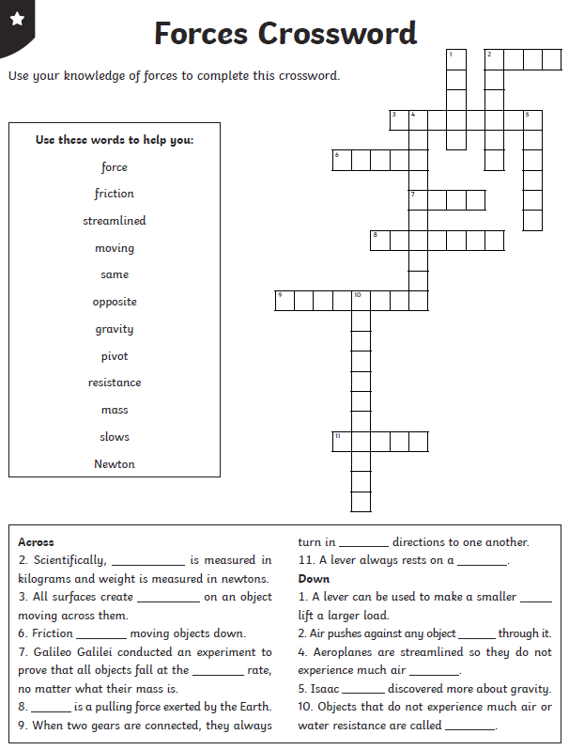

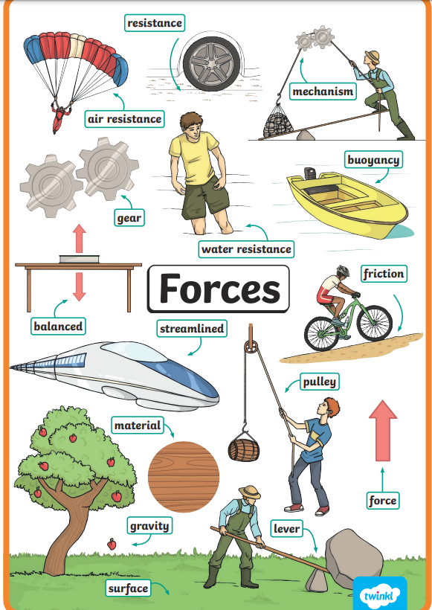

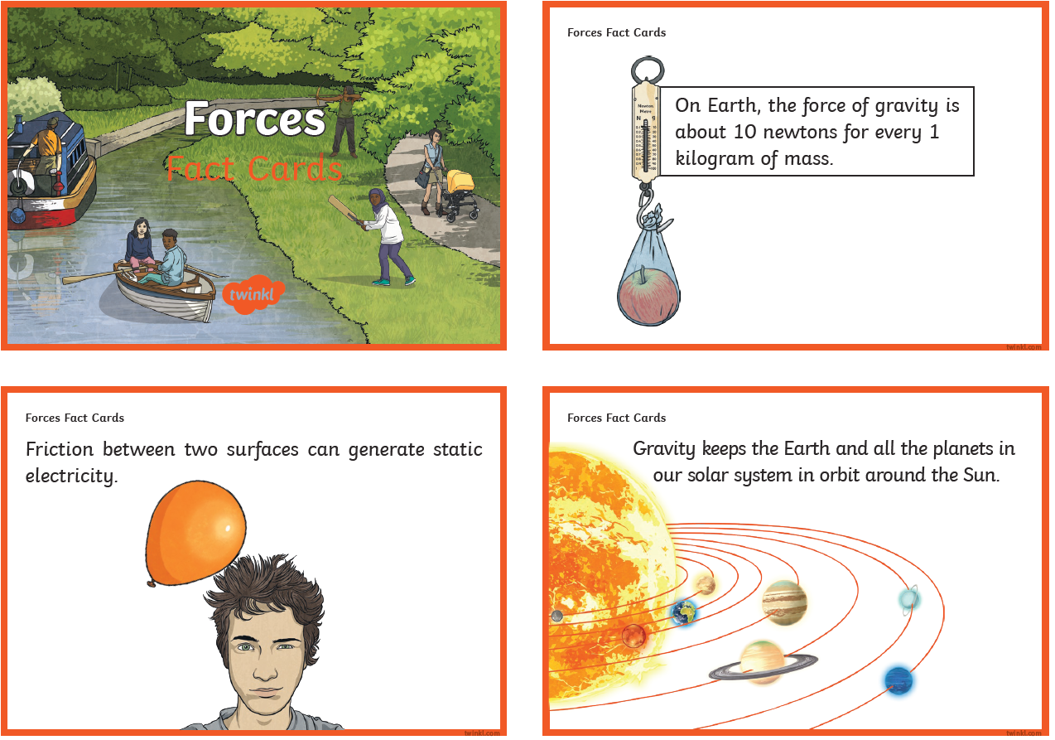

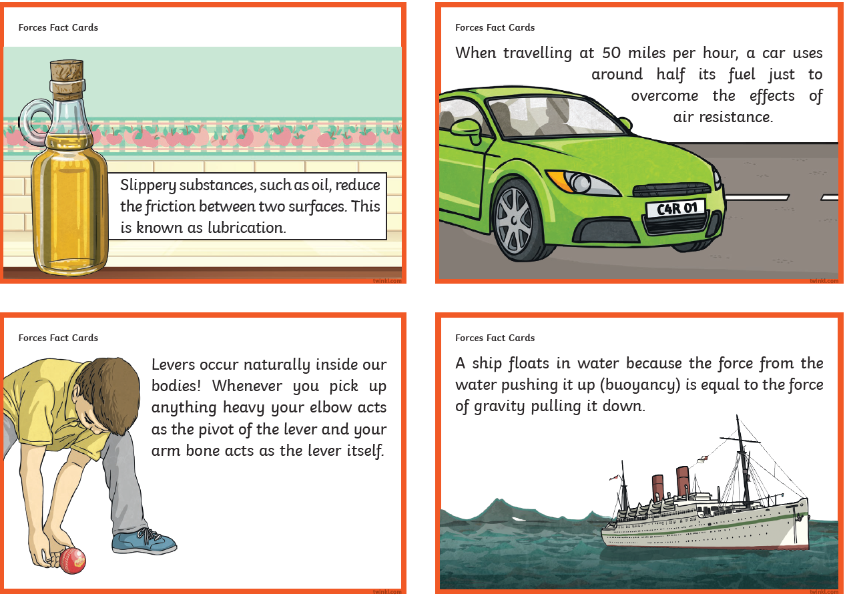

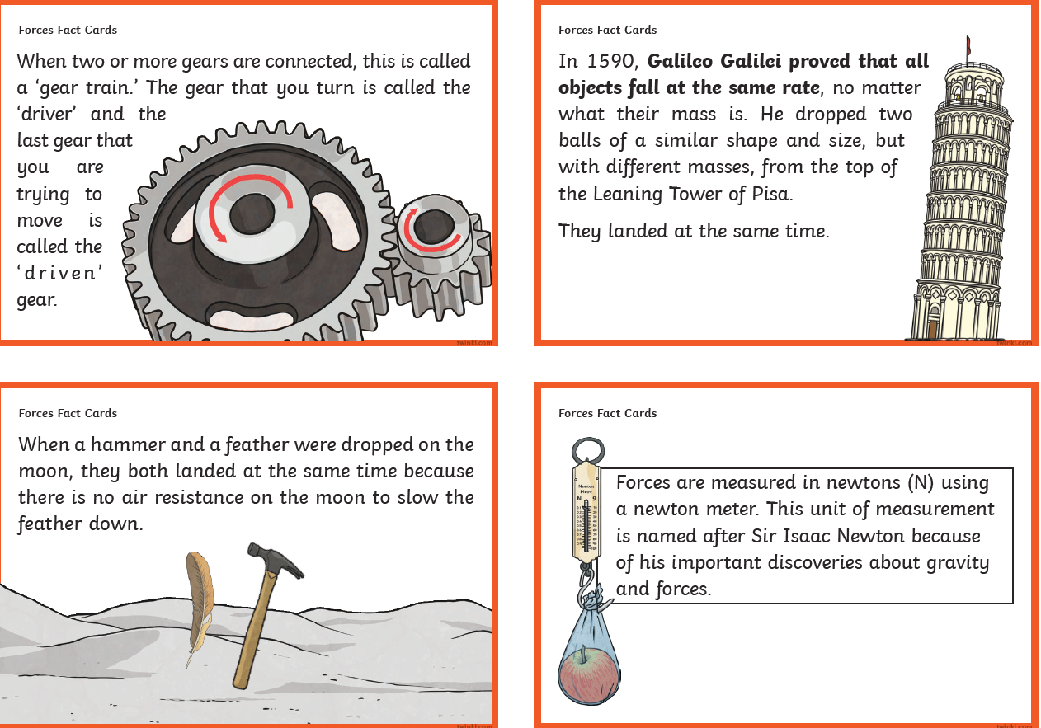

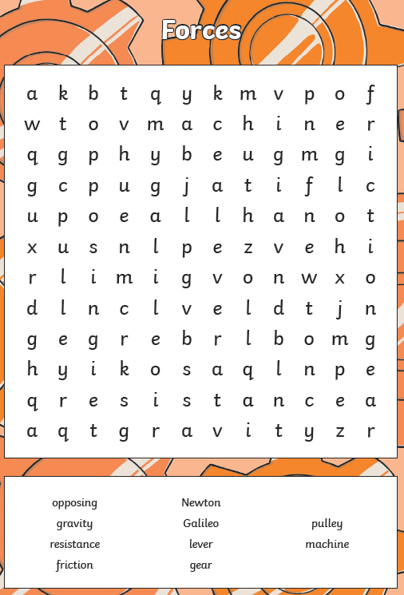

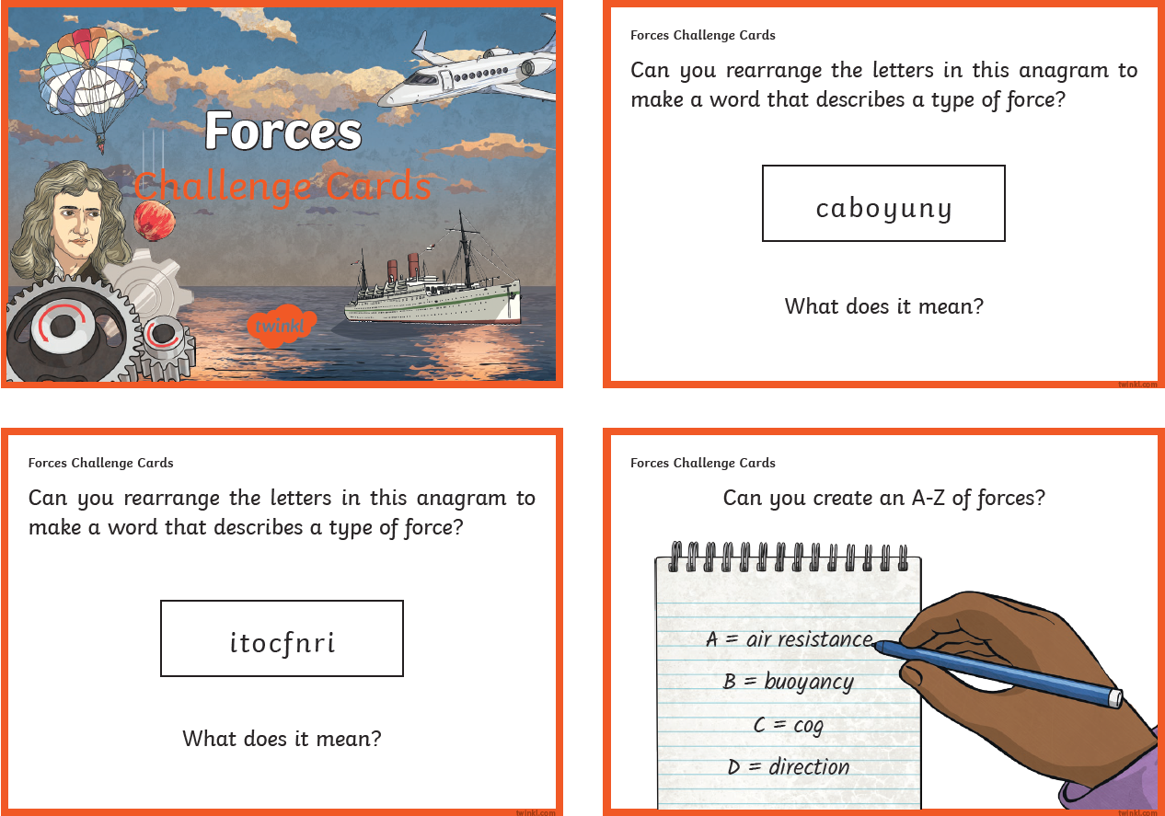

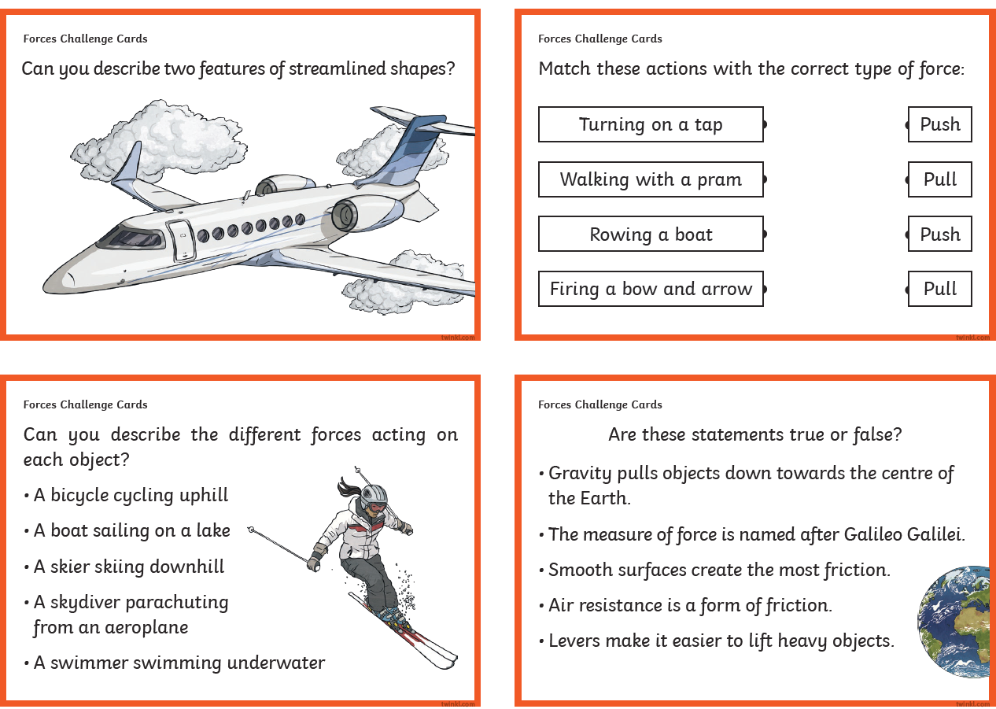

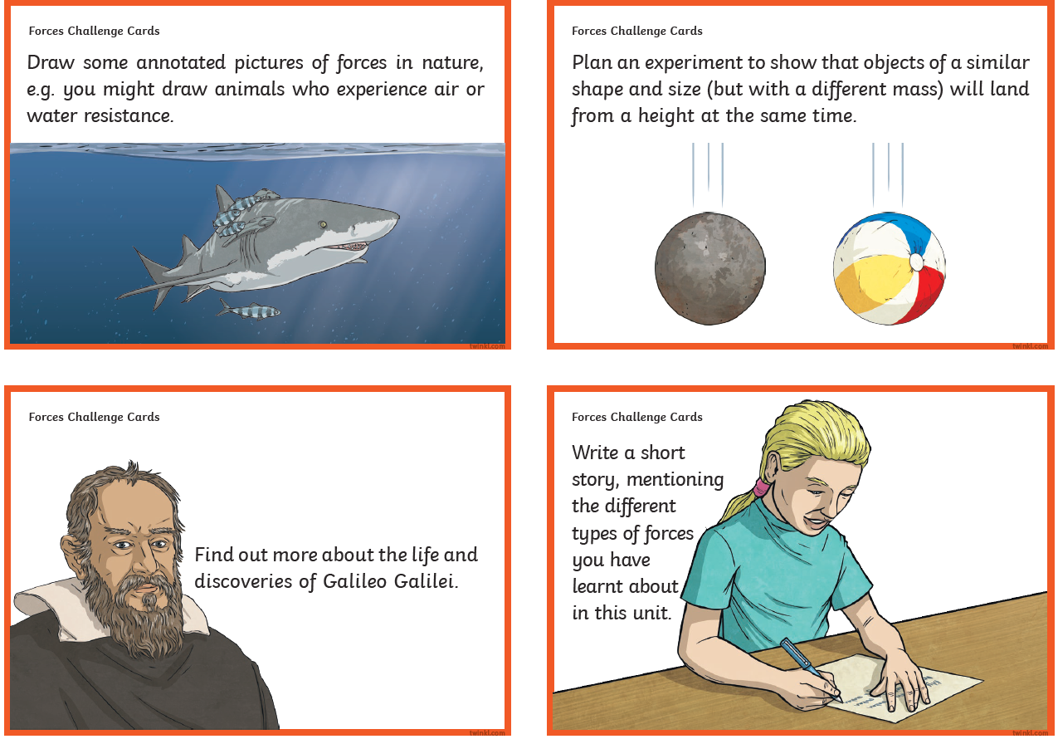

|  |  |  |
| --- | --- | --- |
|  | **Videos** | **Activities** |
| Forces | <https://www.bbc.co.uk/bitesize/topics/znmmn39><https://www.bbc.co.uk/bitesize/topics/zvr3nrd><https://www.bbc.co.uk/teach/class-clips-video/science-ks2-the-work-of-galileo-galilei/zh69t39><https://www.bbc.co.uk/teach/class-clips-video/science-ks2-the-work-of-sir-isaac-newton/zkw3qp3> | **Out and about – the local area**  - If you are lucky enough to be near one of the mediums covered,  pupils could explore the design of different boats, cars or planes as part of learning about air or water resistance.    **Out and about – further afield**  - Visit the Science Museum and complete the ‘Great Object Hunt’ to explore the galleries.  Alternatively, book onto ‘Feel the Force’ - a dynamic show all about forces and magnets. |