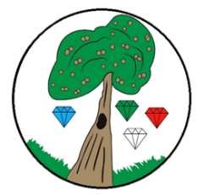Year**: 3** Term**: Spring 2**

**Science: Light**

Pre-Learning Pack

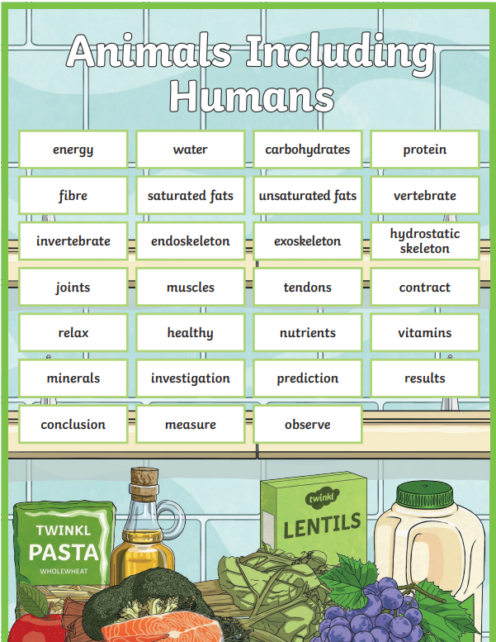

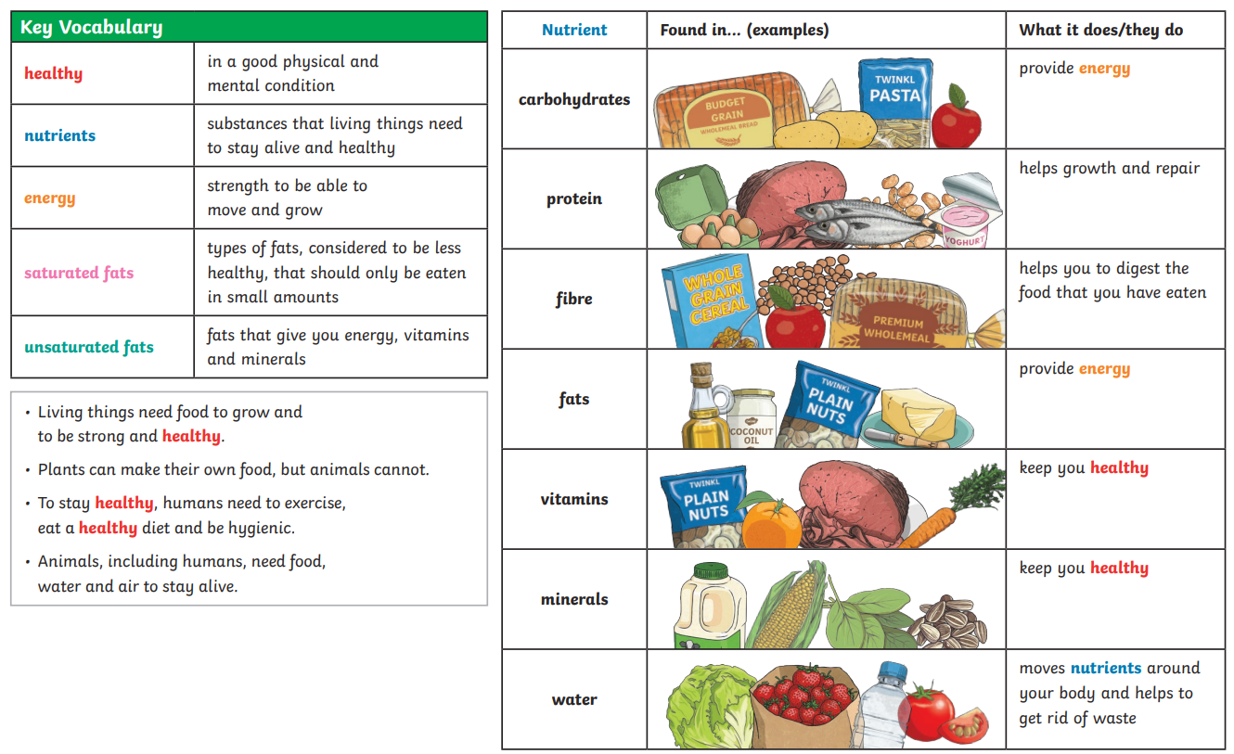

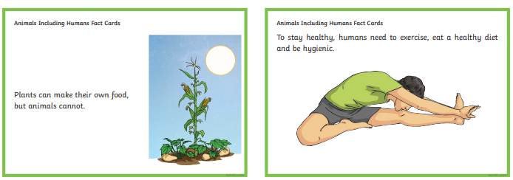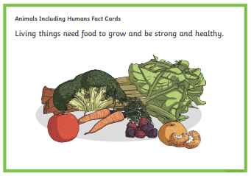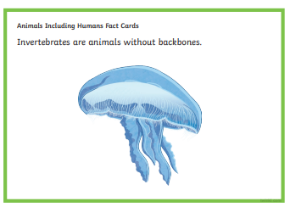

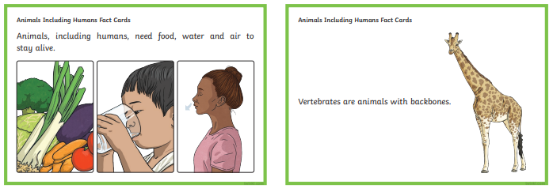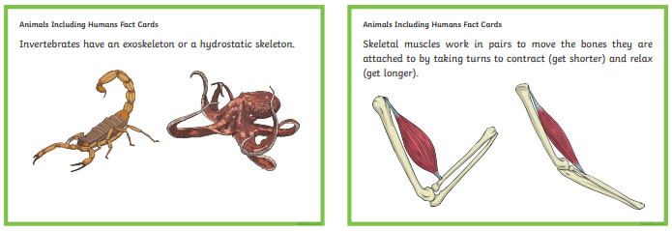

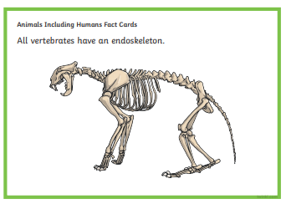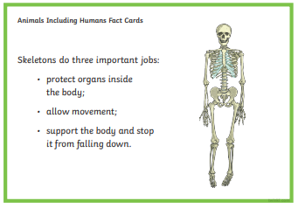

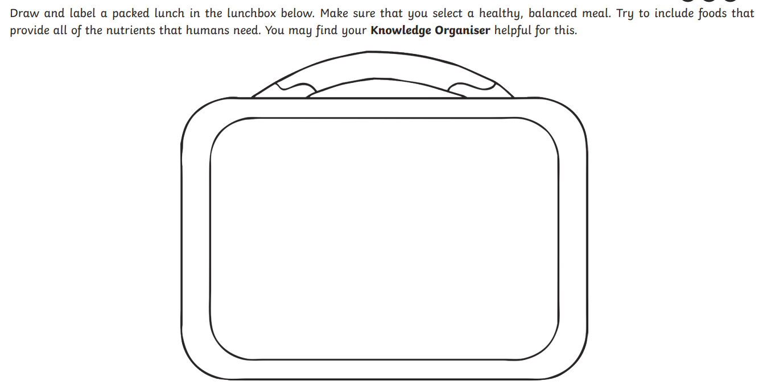

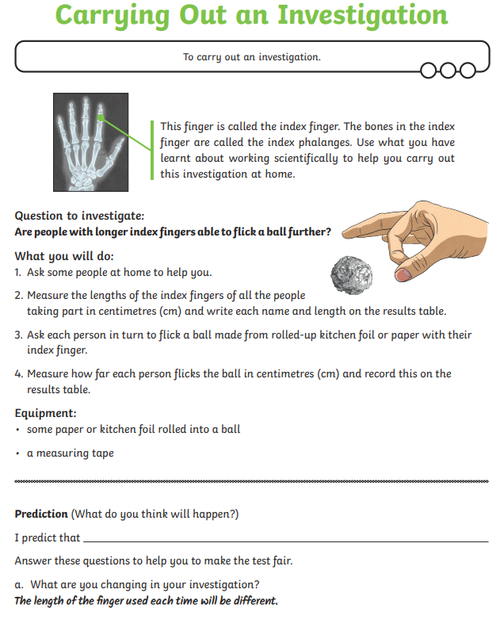

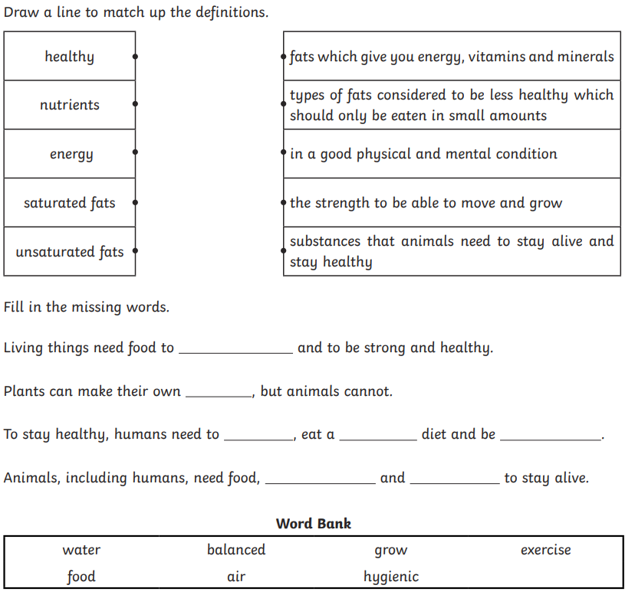

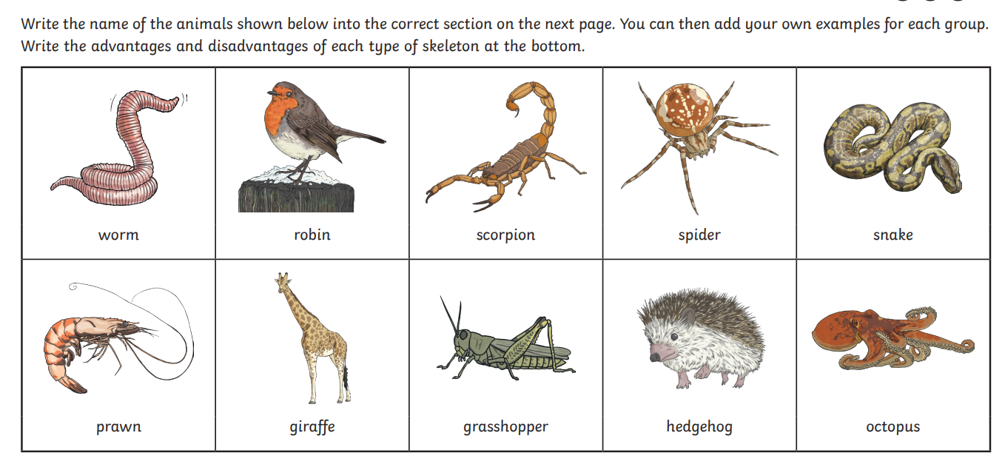

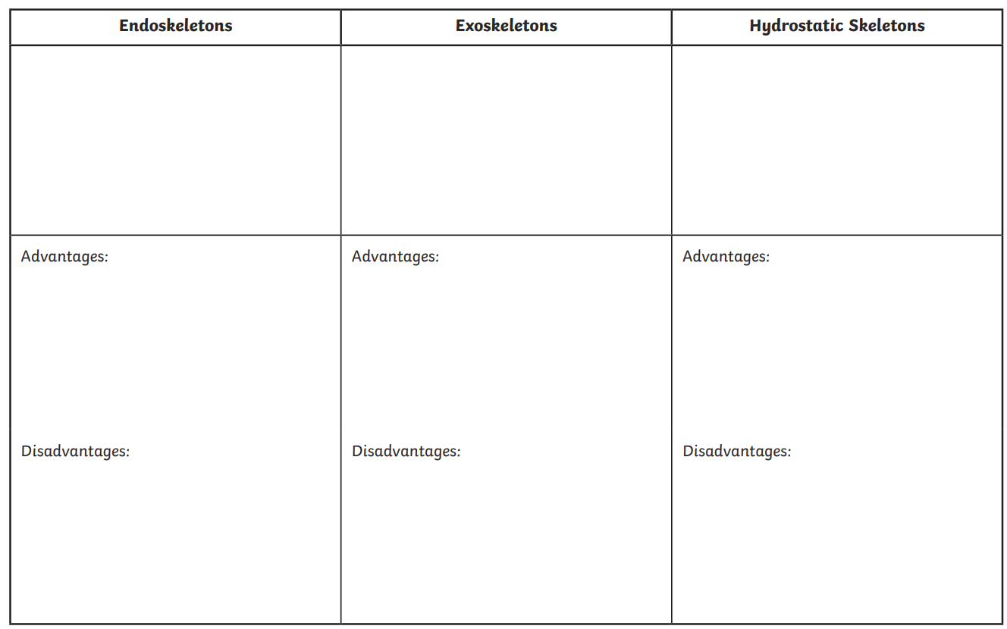

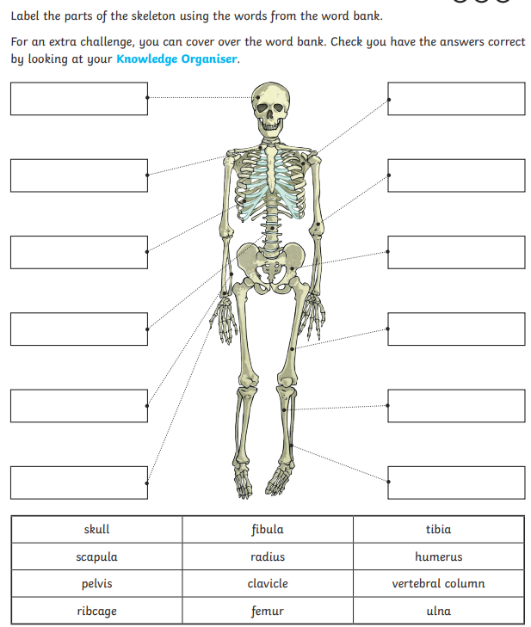

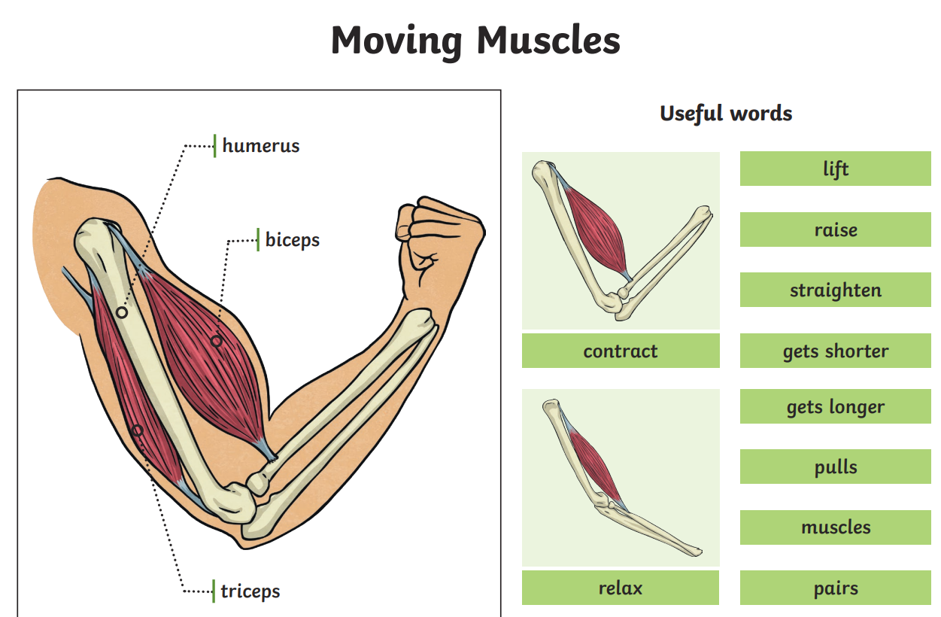

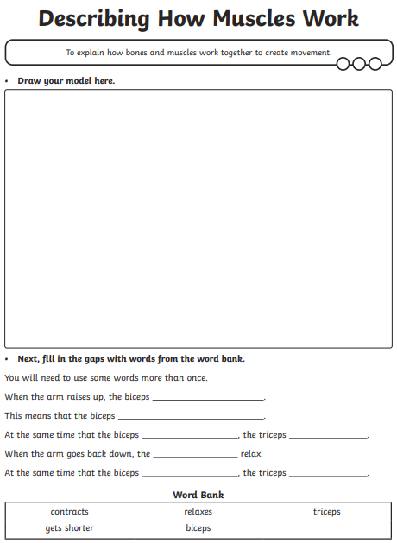

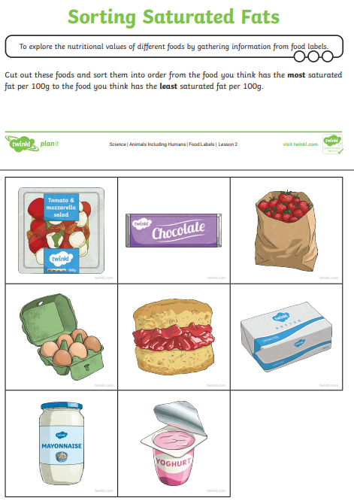

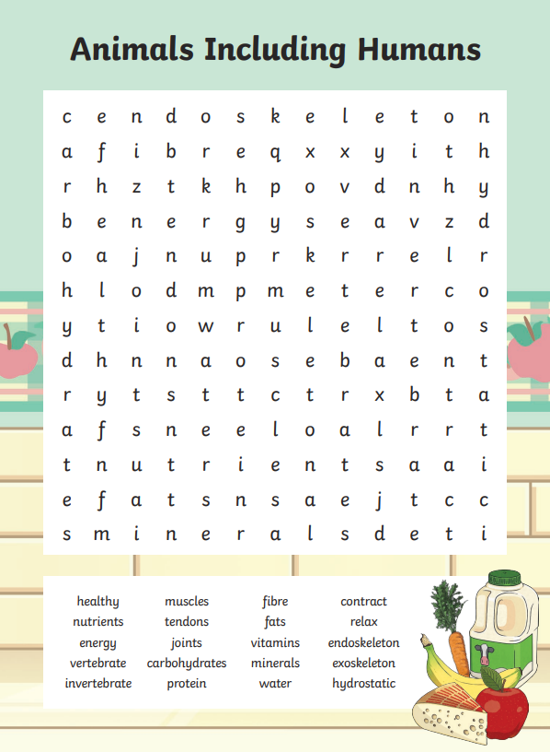

|  |  |  |  |
| --- | --- | --- | --- |
|  | **Videos** | **Activities to complete** | **Home activities** |
| **Forces**  **&**  **Magnets** | [How to use Science Journal for Kids in the STEM classroom — and why. (youtube.com)](https://www.youtube.com/@ScienceJournalforKids)  NHS Eat Well guide:  <https://www.nhs.uk/live-well/eat-well/food-guidelines-and-food-labels/the-eatwell-guide/>  How do our bodies get nutrients from food?  [How do our bodies get nutrients from food? | BBC Teach - YouTube](https://www.youtube.com/watch?v=eSEYPO30AN0)  What does your skeleton do?  <https://www.bbc.co.uk/bitesize/topics/zcyycdm/articles/zf284xs>  How do your muscles work?  <https://www.bbc.co.uk/bitesize/topics/zcyycdm/articles/ztwcbqt> | | Be food smart healthy eating ideas:  <https://campaignresources.phe.gov.uk/schools/resources/be-food-smart-ks2-toolkit>  Human body games:  <https://www.cokogames.com/tag/human-body-games/>  Healthy lunchbox recipes:  <https://www.nhs.uk/healthier-families/recipes/healthier-lunchboxes/>  Visit the Science Museum, London and explore the biology of the human body:  <https://www.sciencemuseum.org.uk/objects-and-stories/understanding-body>  Visit London Zoo to discover all the animals:  <https://www.londonzoo.org/> |