**Spring 1 -Forces – Lesson 1 to 3**

**Lesson 1** Investigation to test Galileo’s’ Equivalence Principle’, ie will two objects of different weights dropped from the same height land at the same time?

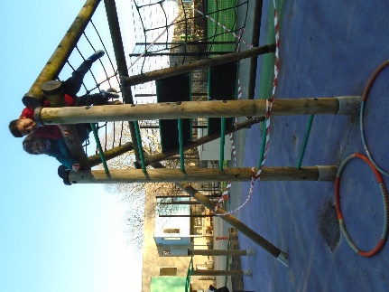 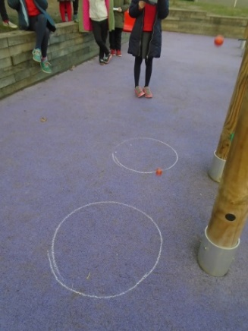 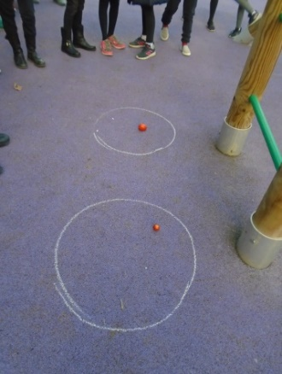

**Lesson 2** We made autogyros out of paper and dropped them from heights of 1 and 2m – we recorded the time taken and filmed the drops using, ‘Slo-Mo’. We repeated the experiment several times to ensure accuracy. By doubling the information for the 1m drops -we could compare it with the 2m drops and noticed that it was comparatively slower when dropped from a lower height. When objects are dropped from height – they speed up this is called momentum.

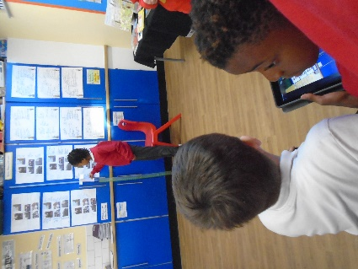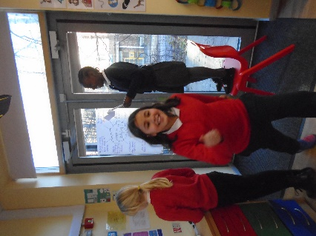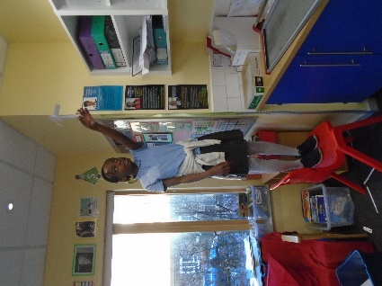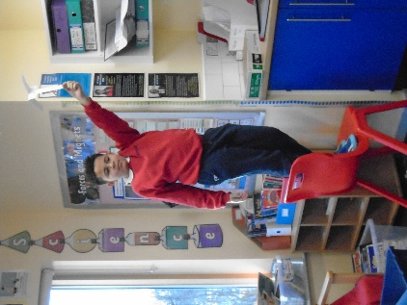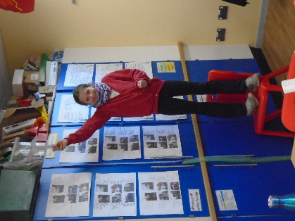

Lesson 3 – Looking at the impact of air resistance by making different sized parachutes.

