Feeling downie? Eat a brownie

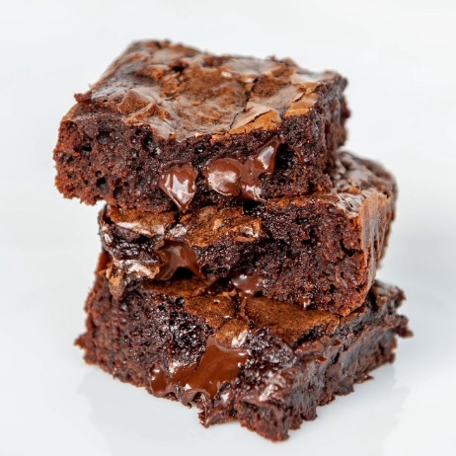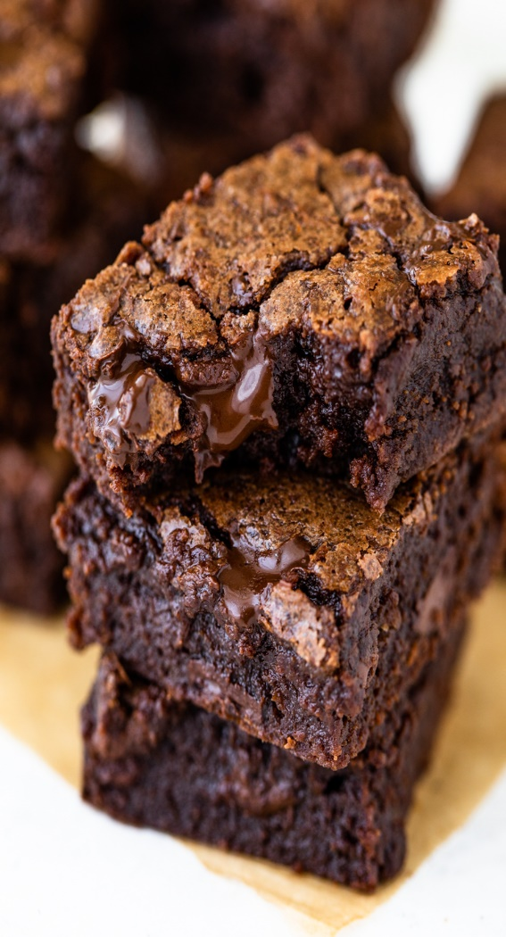

Welcome to our Bessemer’s school Enterprise Project, where we will be selling delicious food.

WHY SHOULD U BUY THESE BROWNIES?

You should buy our scrumptious brownie as everyone needs a sweet treat in their life.

Outside main school Thursday 13th July, 3.30

You know u want some -treat yourself!!!