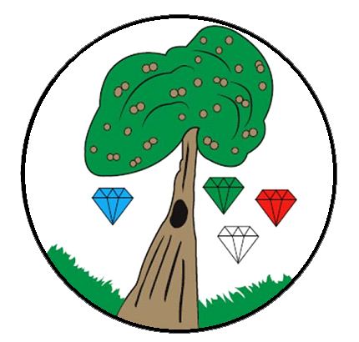

**Art and Design**

**Intent, Implementation and Impact**

**Intent**

At Keyworth Primary School, we believe that it is every child’s right to have the creative freedom to express themselves and their individuality; to be curious and inspired; to explore different ideas, themes, styles and cultures in an environment that is respectful and values inclusivity and innovation. Through our art curriculum, we aim to equip our children with the knowledge and skills needed to investigate, experiment, refine and create: each year, building upon their learning from the previous year. We encourage our children to think critically about their own practice and that of others, to reflect upon and be inspired by the work of great artists from different countries and cultures and recognise the ways in which their work has contributed to and reflects society.

**Implementation**

At Keyworth, art and design are taught progressively in weekly lessons that are linked to the children’s current topics where possible.

Our children develop skills in drawing, painting, sculpture, collage, printing and textiles, revisiting and building upon their learning with each new topic from early years to Year 6.

Each unit focuses on a particular skill, theme and outcome, providing our children with the opportunity to investigate, research, experiment and refine. Sketch books are used to record, practice techniques and test out ideas. The children are encouraged to think critically, to reflect on their ideas and progress whilst making notes and annotations as they go.

Opportunities are provided for the children to take their creativity outside of the classroom: to practice and develop their skills, through activities, tasks and competitions linked to whole school projects and events. This in turn allows our children to share their work and ideas with the wider school and local community. The children are also encouraged to apply their learning and creativity across all other subjects, whether it be science, geography or maths; enriching each one whilst perpetuating the ideas that underpin artistic learning: creativity, reflection and critical thinking.

**Impact**

The impact of our art curriculum is evident in several ways: through the children’s sketch books, which follow them as they move up the school, through each art outcome at the end of every project and in the work that is displayed in the school or classroom. It is also evident in the discussions and debates surrounding their practice and the ideas that develop along with their skills.

At the start of each unit a cover page is placed in the children’s sketch books, for the children and teachers to refer to throughout and measure their progress against at the end of each unit. These include the vocabulary, skills and objectives the children will focus on as they carry out their projects. This document is used by both pupil and class teacher to monitor progress and identify any gaps that need to be addressed. Class teachers use this, along with each pupil’s sketch book (research and preparatory work) alongside their final piece to make a final judgement.

Learning is monitored through book scrutinies, learning walks and discussions with children and colleagues, with additional views shared through ‘pupil voice’.